WOOD RIVER FIRE PROTECTION DISTRICT 2022 Final Report
Chain of Survival
Grant Amount: $18,526.00

The story of this grant’s impact has not been written but assuredly will be meaningful. It has been a lengthy process to this point as supply chain issues severely hampered any immediate progress. However, we have recently taken ownership of the AEDs crucial to this project and are excited to begin. Over the course of the last year, we have seen awareness of AEDs and cardiac arrest resuscitation grow through at least one national event of note. In addition to increased training and widespread deployment of AEDs among first responders, private organizations and individuals have begun to reach out and seek resuscitation training. It is encouraging to see the interest in and support of the well-being of our community members. We are pleased to capitalize on this momentum and serve our community as leaders in a link of the chain of survival.

The premise of our project and grant request is to improve access to a critical link in the chain of survival, early defibrillation. To realize this within the community our objective was to purchase a fleet of AEDs and strategically place them with first responders in the Wood River Valley. This effectively would enhance our community members’ access to this life saving intervention. Our project has just begun but the impact we intend was recently demonstrated by a local event. An identical AED deployed by an off-duty firefighter resulted in early defibrillation, effectively saving a valley citizen’s life. The use of the device prior to the arrival of EMS responders assisted in converting this patient’s heart from a lethal rhythm to a stable one which allowed for transport to definitive care. Delaying the resuscitation effort by not having an AED available with an off-duty responder could have easily been the difference in this patient’s outcome.

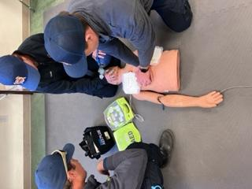

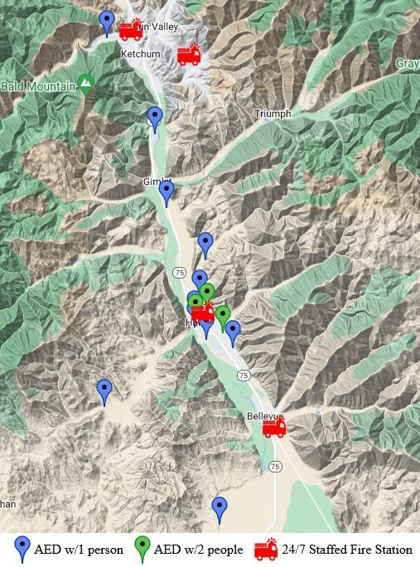

All funding requested was for equipment. To execute this project WRFR has the additional resources required to bring it to completion. The difference in actual expenses v requested is related to a change in the brand and model of equipment purchased. Due to supply chain issues on the manufacturers’ side, we were unable to purchase the equipment originally quoted. This required us to move to a comparable model which favors equipment already a part of our daily operations.

Expenses | Amount requested from WRWCF | Actual Expenditures
Salary and Benefits
Training & Professional Development
Travel
Equipment | $18,526.00 | $18,598.66
Printing, Copying & Postage
TOTAL | $18526.00 | $18598.66

