THE SPACE 2022 Final Report
Forward Learning Scholars
Grant Amount: $18,900

Grant Program in Review

Hunter was referred to the Forward Learning Scholars program by a concerned community member. He had a history of academic struggles and significant challenges at home and was spending a lot of time alone.

At first, Hunter was reluctant to come to The Space. For nearly two months he didn’t engage with tutors or other students. He was failing his classes and was quick to shut down when asked about school. Eventually Hunter asked for help with a late assignment, and soon he was regularly working with tutors on his homework.

Hunter writes, “I wanted my grades to be better than Bs. I used to have grades that were really low. Now I have some A’s and I am going to keep trying…The Space makes it easy and fun.”

Hunter’s transformation didn’t happen overnight. He is sticking with it and we are committed to helping him reach his goals.

Objectives & Outcomes

The objectives of our grant focused on student attendance and grades.

This year, we have worked with 29 students within our FLS program. Of those students, 11 started the year with us and have maintained attendance. We have added an additional 9 students over the course of this year. Over the past few months, the team has focused on “graduating” five students out of FLS and into other programs at The Space. 100 % of students currently enrolled in FLS attend consistently, and 100 % of students/families who are eligible to return to programs at The Space have indicated that they plan to do so.
Academic goals are different for each student, but parents and teachers consistently report an improvement in grades.
Additional successes are anecdotal but not to be overlooked:

- A student who wrote on his end of year summary: “(my goal was) to get the best grades possible…AND I DID!”

- One of our bilingual students who struggled with his confidence was chosen to be one of two speakers at 8th grade graduation.

- A student who has been receiving academic interventions since elementary school and whose academic progress has been tracked closely by teachers is no longer being identified as a student of concern by the school.

Photos – SEE BELOW

Budget

Expenses | Amount requested from WRWCF | Actual Expenditures
Salary and Benefits (Tutoring Staff) | $14,0000 | $13,897
Salary and Benefits (Programs Administration) | $2,000 | $2,000
School Supplies | $600 | $787
Educational materials | $1,500 | $1313
Snacks | $800 | $903
TOTAL | $18,900 | $18,900

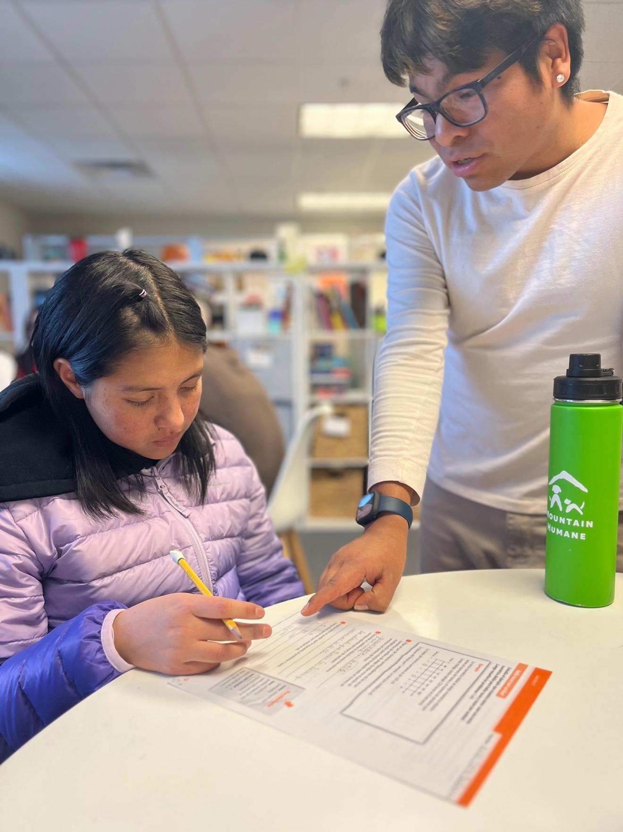

Bilingual Math Tutoring
1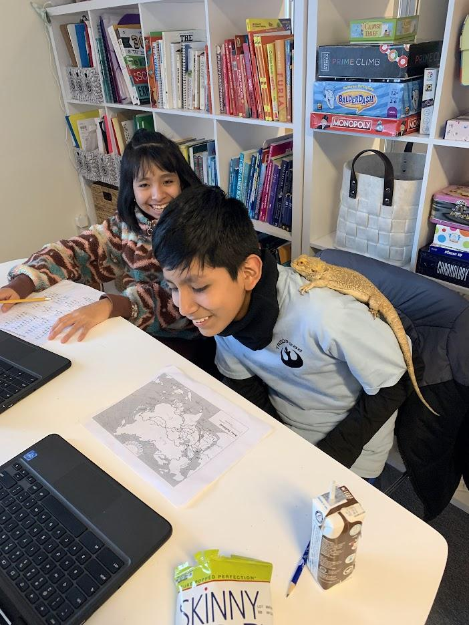
Geography homework is more fun with the help of a Bearded Dragon
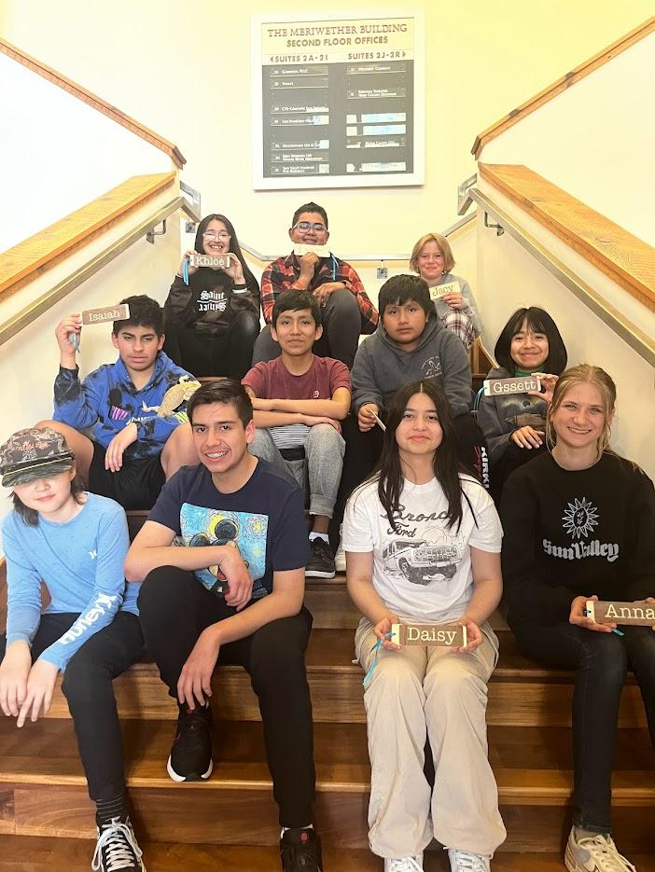

Forward Learning Scholars gather at the end-of-year celebration.

