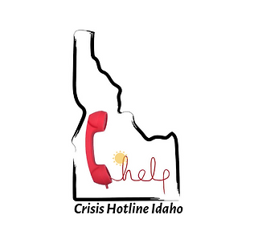

THE CRISIS HOTLINE 2022 Final Report
“My Life Matters” Enhancement
Grant Amount: $20,000.00

Grant Program in Review
As an organization that has been on the “front line” of receiving suicide calls from 11-year-olds to delivering suicide prevention awareness outreach to our youth for years, it became clear to us locally that a missing piece to prevention for the youth was the messaging to the parents and our community at large. Many adults are not aware, or do not take into consideration how our brains develop emotionally from birth. We are on the cusp, locally and worldwide, of normalizing conversations over our emotional health and developing a better sense of connection between our mental health & physical health.
This program is one of many avenues that has truly cracked open the doors of awareness. It is a humbling experience to see a parent not feel defeated in the quest to help their child and say, “Thank you, I never meant to hurt them by what I was saying, and I didn’t realize how impactful those words can be”.

Objectives & Outcomes
Deliver program to 200 people.
    - We were able to deliver to over 276 known individuals in the community at the different venues, from Wiseguys Pizza outreach, Rotary Club, Carey School, Country Chalet and Sun Tree Hollow Mobile Home Parks, our partnerships with The Community Table and 5B Suicide Prevention Alliance as well as hosting Kevin Hines together with his documentary at the City of Hailey’s Town Hall.
    - At each event and outreach, we provided consistent and reliable information on brain development, resiliency skills and the signs of suicide.
    - Most of the results/survey’s remitted shared that they appreciated the knowledge, and they were interested in learning more.
    - A major challenge we faced in our presentation was having to stop using some materials that had previously been authorized. The tools are still valid and remain, just the format of the delivery was stopped. It had to do with the “Know the 5 Signs” Campaign. We made necessary adjustments.

Kevin Hine Suicide Prevention Special Event held in September 2022 (see below)

Budget
Total Amount Requested and Received $20,000.00
Expenses | Amount requested from WRWCF | Actual Expenditures
Salary and Benefits | 12,000 | 17,000.00
Outreach/Events | 5,000 | 12,260
Travel | 1,200 | 1,200
Marketing | 800 | 1300
Equipment | 0 | 477
Printing, Copying & Postage | 1000 | 1000
TOTAL | 20,000 | 33,237
