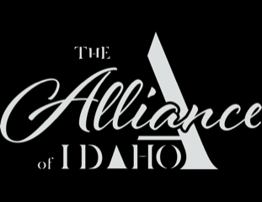

THE ALLIANCE OF IDAHO 2022 Final Report
Legal Support
Grant Amount: $20,000

Impact:

2022 was yet another big year for The Alliance, thanks to the support of the WRWF:
- We hired Cristina Romero as our full-time Legal Assistant,
- We hired immigration attorney Luis Campos as our full-time Legal Director,
- We moved into a bigger office across the street from the Hunger Coalition to accommodate our growing staff, and
- We prepared to launch a new program, “Project Solo: Special Immigrant Juvenile Status Program,” designed to help local immigrant children, who have been abandoned, abused, or neglected by one or both parents, apply for permanent residence.
When Cristina answers The Alliance’s hotline, callers say, “They told me to call you” or “They said I could trust you.” And the need for ethical and affordable legal services is only increasing. Becky is one of two Latina EDs in the valley; Luis is the only bilingual immigration attorney in the valley; and The Alliance is the only group that takes on asylum cases in Blaine County. Under Becky’s leadership, we have become a trusted resource for legal services and for connection to other social services.

What we accomplished in 2022:
- Our legal team clocked more than 500 hours,
- Luis Campos offered 120 one-hour consultations to new clients in our community,
- The hotline receives 20-25 calls every day (which is the number of calls we used to receive in a year!),
- The Alliance has more than 20 active asylum cases, and
- The Alliance has begun work on our first 3 SIJS cases, helping vulnerable children in the valley.

Team Photo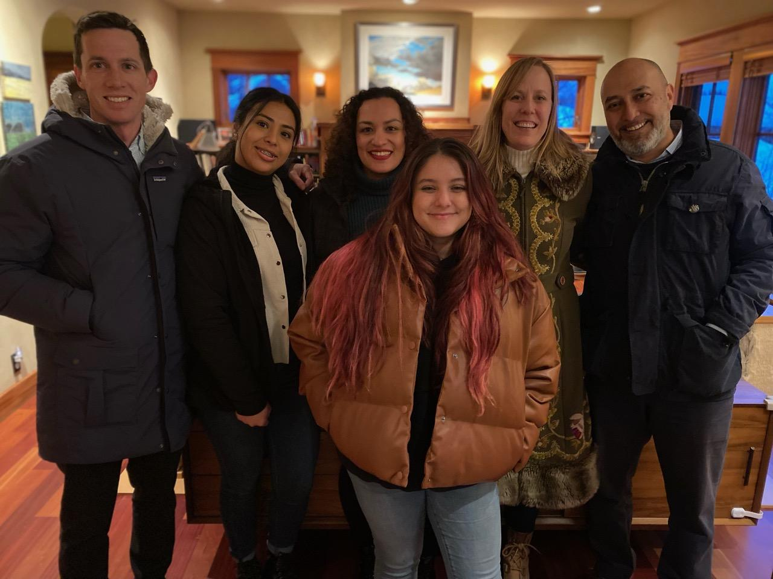

TEAM PHOTO
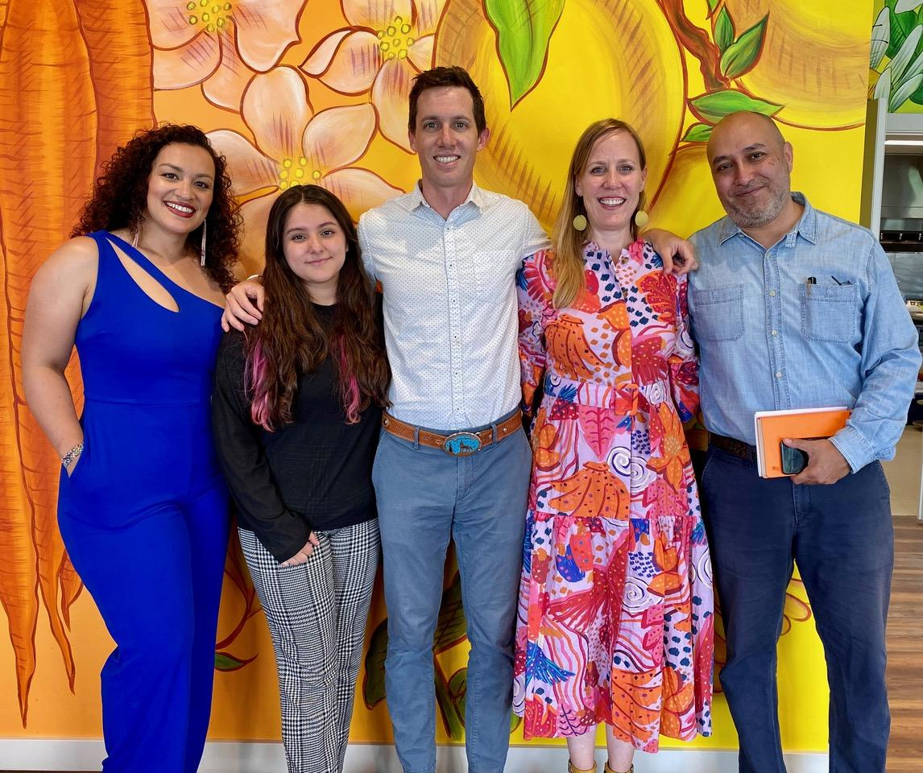

Expenses
EXPENSES | AMOUNT REQUESTED  FROM WRWF | ACTUAL EXPENDITURES  From July 2022 to May 2023
CONTRACT FEE FOR  LEGAL SERVICES WITH  LUIS CAMPOS | $20,000 | $57,240
TOTAL | $20,000 | $57,240

