SWIFTSURE RANCH THERAPEUTIC EQUESTRIAN CENTER 2022 Final Report
Safety Surround Wall
Grant Amount: $14,200

Grant in Review

The impact of this grant is that the main arena is now surrounded by a solid wooden safety kick wall. The solid wall significantly enhances horse and rider safety by protecting riders’ knees, feet and legs from possible entanglement when riding near the edge of the arena. The wall is constructed at an angle with the top of the wall leaning away from the bottom. This provides space for a rider’s foot and greatly reduces the chances of knees or feet contacting the wall. As an additional benefit, the solid construction will contain and conserve the arena footing material, which WRWF so graciously helped us replenish last year.

With the mounting price of building materials, we were not surprised that our final costs outpaced our initial estimates. However, we are proud to report that our Ranch Foreman was able to design and complete the project in less time that we anticipated, greatly reducing our estimated labor costs.

Photos – See Below

Budget

Expenses | Amount requested from WRWCF | Actual Expenditures
Lumber | 7,040 | 9,115
Installation Labor Cost | 5,000 | 3,600
Paint & Hardware | 2160 | 2,500
TOTAL | 14,200 | 15,215
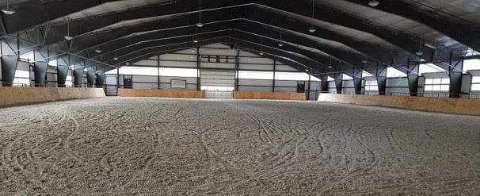
View showing the new safety kick wall surrounding the arena.

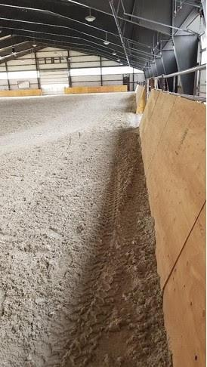
A rider’s-eye view showing the angle which keeps riders’ knees or feet away from the wall.

