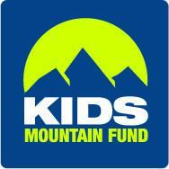

KIDS MOUNTAIN FUND 2022 Final Report
Rota-Rippers Lease Package
Grant Amount: $6,500

Grant Program in Review:

The growth witnessed at the hill is palpable. Kids develop grit, courage, joy, resilience, and technical skills from a sport that identifies us as a community. Rota-Rippers provides inclusivity to families without the financial means to participate. The lease package offers accessibility to families without the knowledge and understanding of what it takes to engage in a technical and risky sport. One child who recently arrived from Peru stands out the most. He was quiet at first, spoke very little English, and a friend encouraged him to sign up. He developed a love and joy for the sport skiing every weekend building technical skills, developing his English language faster, and found a niche where kids accepted him quicker. There are so many stories like this one where kids improve self-esteem due to involvement in this program. Kids work hard to learn new skills, make and strengthen friendships, feel good about themselves through skill development, and enjoy recreating outside. When so many young people struggle with mental illness this program helps keep depression in check.

Objectives and Outcomes:

In the 2021/2022 winter season KMF provided 104 kids with lease packages from two 4- week sessions of the Rota-Rippers elementary school ski/snowboard program at Rotarun. Most of the kids we serve receive reduced or free lunch and Rota-Rippers provides an opportunity that would not otherwise be available to these kids. Inclusivity and accessibility are priority values for KMF to meet our mission. The kids thrive in this program, the parents appreciate their ability to participate. I see kids today in town and they say hello, some give me a hug remembering how much fun they had and I know this program has enriched their lives. Developing skills is beneficial to maintain self-esteem, which in turn reduces mental health struggles that kids face. Physical activity helps reduce obesity. We are making a difference in kid’s lives with long lasting positive impacts. We are building resilience in kids, and making our community stronger and more vibrant from celebrating diversity and making this program accessible. Teaching skiing to first generation kids is very rewarding. The only challenge is how to grow the program to reduce the waitlist that builds year to year. The reality however, is that Rotarun has a carrying capacity and we offer the maximum amount of kids on the hill at one time without compromising safety.

Photos:

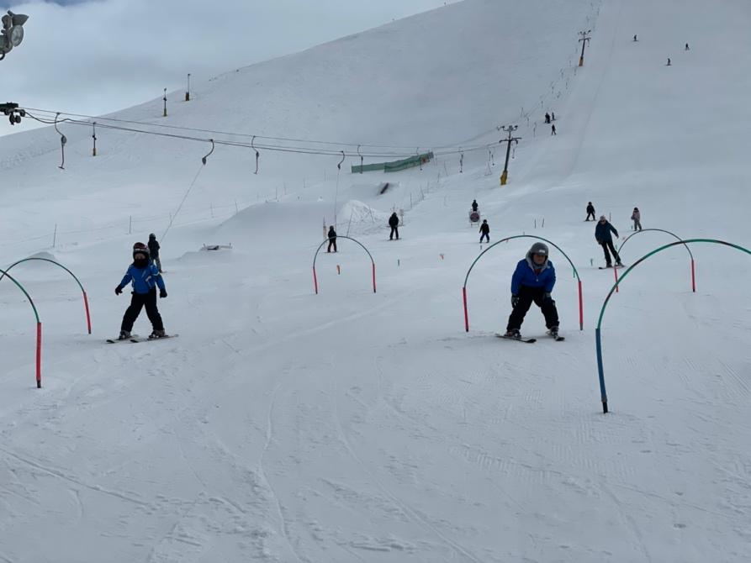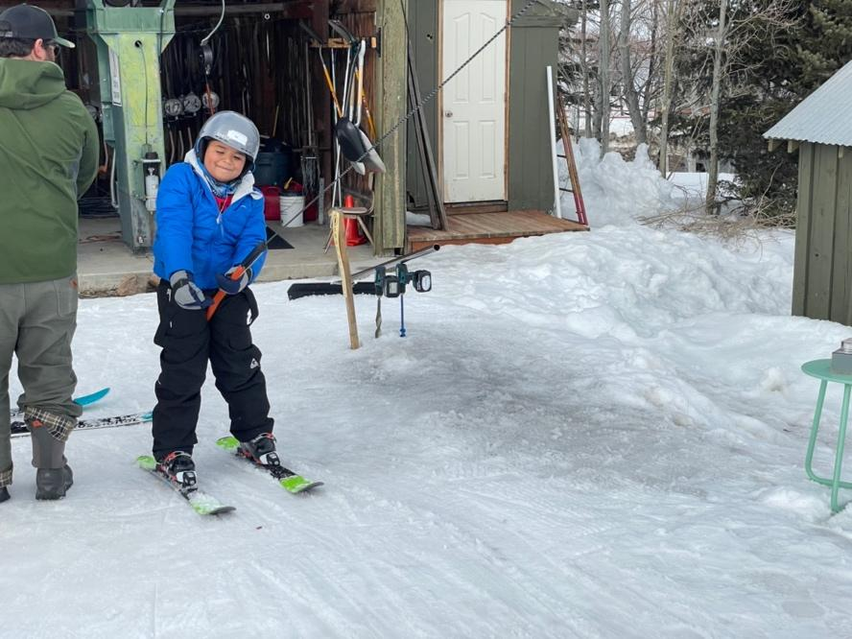
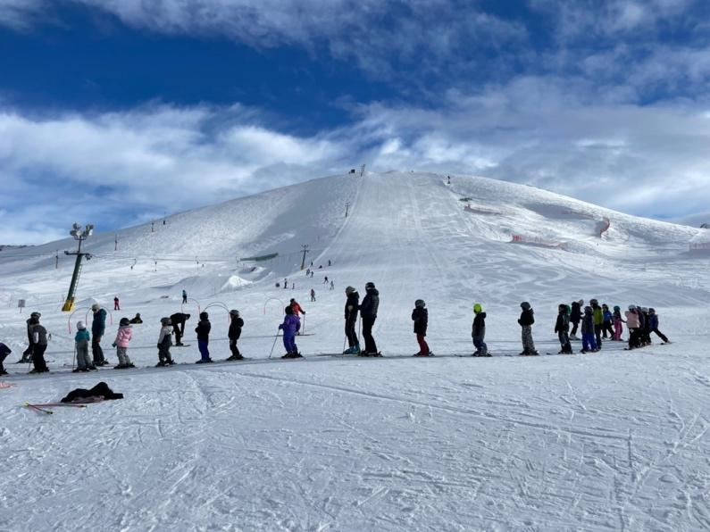

Budget:

Expenses | Amount requested from WRWF | Actual Expenses for Rota-Rippers Leases
Leases: 50 kids session #1 54 kids session #2 | $6,500 total received from WRWF | $4,950.58 Session 1  $5,349.59 Session 2
Total kids received leases = 104 |  | $10,300.17 total lease package cost

I was able to cover costs for all the Rota-Ripper lease packages because I received some additional small grants from other sources in 2022. Each year costs go up for lease packages a little bit, but Sturtevant’s provides KMF a discount on each lease. This is truly a community supported program.

