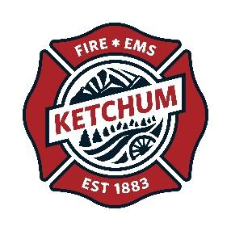

KETCHUM FIRE DEPARTMENT 2022 Final Report
All Terrain Rescue Vehicle
Grant amount: $20,000

Grant Program in Review

The Ketchum Fire Department was fortunate to receive a generous grant of $20,000 toward the purchase of an all terrain rescue vehicle. This vehicle has already served the community well on rescue calls, training and response to fires.

The first rescue the vehicle was used on was an injured mountain biker in the Adams Gulch area. The biker had gone over the handlebars and had a suspected broken neck. Rescue 2 (the new vehicle) forded the creek and drove out the old forest track to the bike trail, then up to the injured person. He rode out fairly comfortably in a litter attached to the vehicle. He was at the hospital in a fraction of the time it would have taken to carry him out by hand.

The Rescue is now outfitted with a litter, tools, winter tracks and summer tires and a custom cover designed to keep injured persons protected and out of the elements.

Objectives & Outcomes

Rescue 2 was put in service late in the summer. It still was used on 4 biker injuries. For the winter it was equipped with tracks and was used on 6 avalanche rescue drills. Fortunately, there were no avalanche entrapments this winter. It is now geared up for summer use again.

Photos

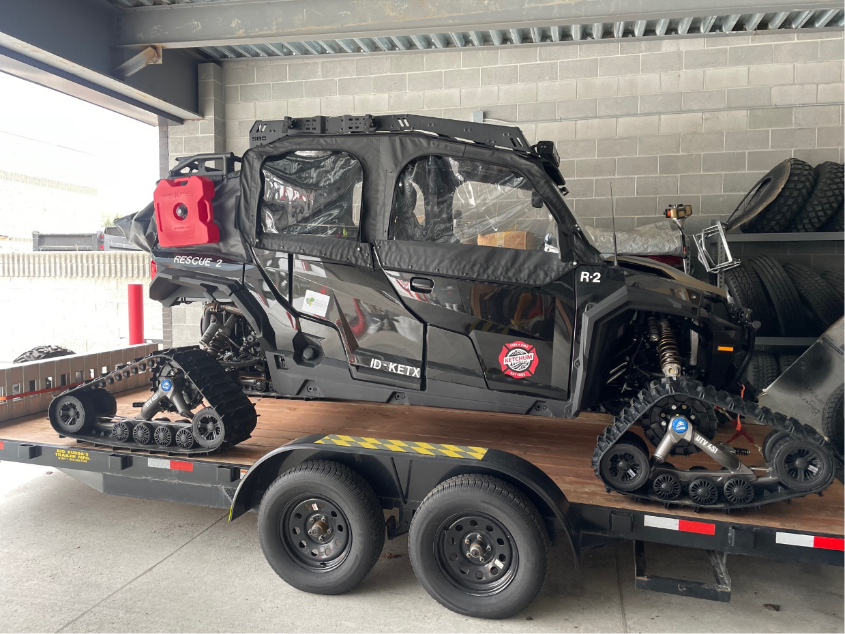

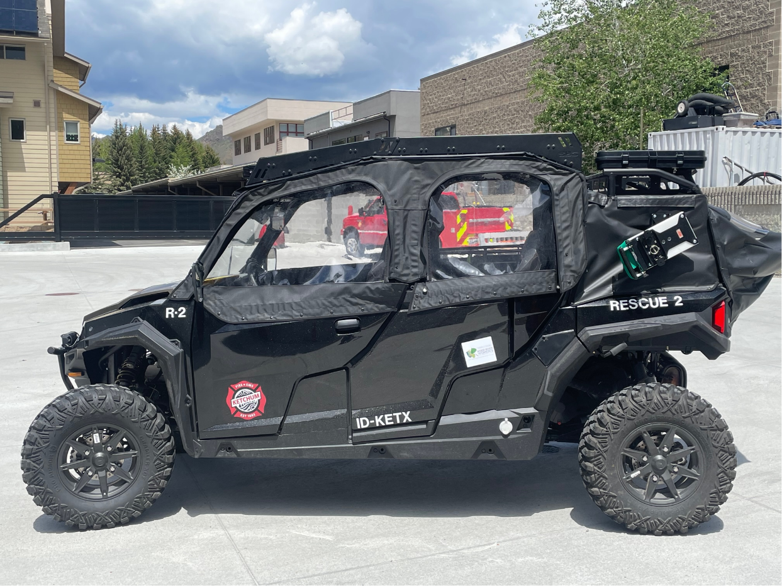

Budget

In addition to the funds donated by WRWCF, $4,000 was donated by the Ketchum-Sun Valley Firefighter’s Association. The City of Ketchum provided the remainder of the funds.

Expenses | Amount requested from WRWF | Actual Expenditures
Salary and Benefits | 0 | 0
Training & Professional Development | 0 | 0
Travel | 0 | 0
Equipment | 20,000 | 46,000
Printing, Copying & Postage | 0 | 0
TOTAL | 20,000 | 46,000

