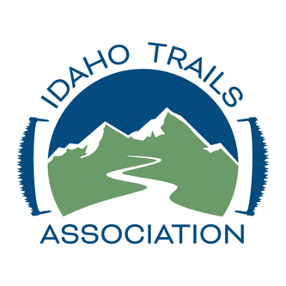

IDAHO TRAILS ASSOCIATION 2022 Final Report
ITA Youth Trail Program 2022
Grant Amount: $6,400

Grant Program in Review:
2022 was ITA’s busiest year yet, with 67 trail projects completed, ranging from one day to one week long. In all programs, we saw the familiar faces of returning volunteers and met over 75 new members through trail project work, engaging 754 volunteers in 11,899 hours of service- our first year to surpass 10,000 hours of volunteer work! Specific to this grant, we planned eight and hosted seven youth projects, one in the Wood River Valley and all that included outreaching to teens in the Ketchum/Hailey area through social media, email, and news releases. We initially had two projects planned in the Ketchum area but had to cancel one in August due to 10 of the 11 youth originally signed up canceling at the last minute due to varying schedule conflicts.
Our North Fork Wood River Youth Project was a success, with 11 volunteers clearing 1.5 miles on the North Fork West Pass Trail as they learned to use hand tools to accomplish trail work and Leave No Trace techniques to ensure their presence had a minimal impact on the campsite and trail. The wet spring impacted this project, with a flood watch in effect at the time; the crew learned to camp and work in wet weather, setting up tents properly and being careful about staying warm enough.
One unexpected outcome of outreaching to youth in the Wood River Valley was the participation of a 16-year-old student in an adult trail project. ITA staff assumed youth would only enroll in youth projects unless participating with a parent, but Pierce signed up for a weeklong adult trail project in the Frank Church Wilderness after clearing it with his parents and the ITA crew leader- and loved it! He is now working on a high school research paper about ADA accessibility in Wilderness and is signed up for another ITA project in 2023. He loves the work and Wilderness and backcountry, and being able to help connect him with the land and find his passion was truly rewarding.
ITA attended Oktoberfest in Ketchum in fall of 2022 to outreach and connect with the community; we were able to talk with people about ITA and encouraged adults with children to look into ITA’s youth program. We also met with Wood River Trails Coalition and have planned a youth project in the Wood River Valley in July of this year.

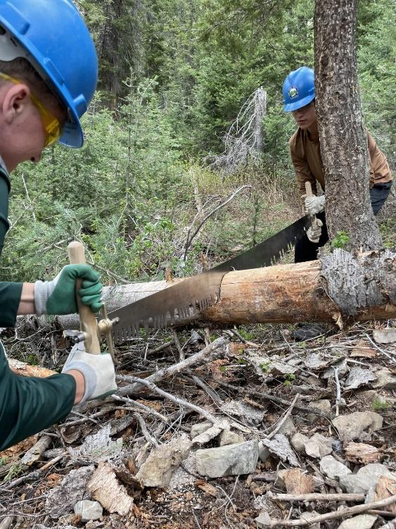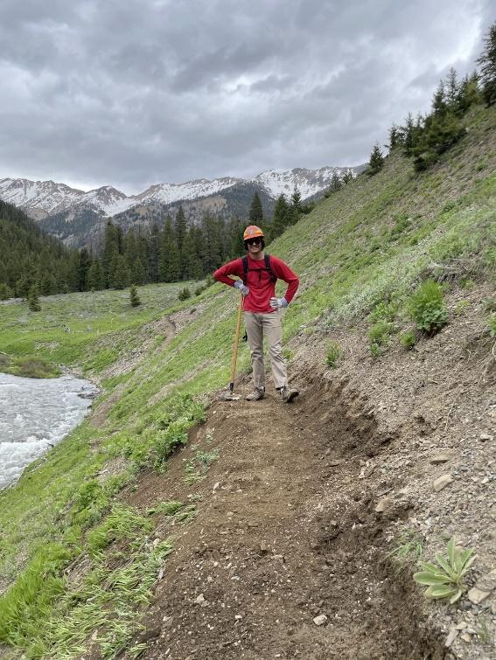
North Fork Wood River Youth Project: logging out the trail and redefining trail tread. *Note: Parents of youth signed photo releases at the project site, so have given permission to use their photos.
Objectives and Outcomes:
Engage youth in two Wood River Valley area trail projects in 2022 | Hosted one; had to cancel one, but did host a youth project in the nearby Grandjean area (southern Sawtooths). Also engaged a Wood River Valley youth in adult project, July 2022, who will return for another project in July 2023.
Teach traditional trail skills and Leave No Trace to youth through volunteer trail work | Nine youth engaged on NF Wood River project; one youth from Ketchum area engaged on adult project; total of 45 youth engaged through ITA youth projects 2022
Improve access to nearby trails for all residents of the Wood River Valley, making it possible for families to explore the area together | Total miles of trail cleared and improved in Wood River Valley and adjacent Sawtooth National Recreation Area in 2022: 27

Challenges: ITA’s youth program is still young (started in 2019, with 2020 canceled due to Covid concerns), and we are still figuring out the best timing for and duration of youth projects between when most Idaho schools are out for the summer and when students return for fall activities and sports. Many youth are busy, between sports and family and summer jobs, and participating in a weeklong project is a challenge. This year, we are trying a variety of project lengths, from one week as the longest, to a mid-length project of four days, to weekend projects. We hope that through geographic and temporal diversity we can appeal to more youth and reduce the number of cancellations arising from schedule conflicts that arise. We are also working to build partnerships with organizations that already serve youth populations and have networks for engaging youth. We are working with Wildhearts Idaho and Wild Science Explorers this summer in this way, and hope to build more connections in the future.

Expense Category | Requested from WRWF | Spent | Notes
Executive Director | $1,100.00 | $1,200.00 | Networking, outreach, Forest Service coordination
Trail Projects Director | $1,550.00 | $2,000.00 | Pre-planned, shopped for, and led NF Wood River Trip, planned and shopped for Sawtooth youth trip
Communications Director | $620.00 | $800.00 | Outreached for NF Wood River Trip, communicated with youth and parents for trip, planned and attended outreach event at Oktoberfest
Gear Shuttle Mileage- Trail Projects Director | $280.00 | $300.00 | Shuttled gear and drove to NF Wood River Project; higher fuel prices increased mileage cost
Per Diem for Trail Projects Director | $300.00 | $300.00 | 30.00/day for meals and incidentals while in travel to support projects
Pack Stock- Haul Gear to Remote Camp | $1,250.00 | 0 | Ended up car camping because of trail conditions and flood warning/need to be close to cars in case of severe weather
Meals for Crews | $600.00 | $950.00 | Higher grocery prices, ouch!
Tools/Safety Gear/Equipment | $500.00 | $550.00 | New hard hats and gloves, replaced folding saw blades prior to NF Wood River trip
Educational materials (journals) and fun swag for crews (t-shirt, sticker) | $200.00 | $300.00 | Crews received t-shirts and stickers and an ITA bandana; youth leaders received the same, plus a youth leader ITA handbook.
 | $6,400.00 | $6,400.00

