BLAINE COUNTY CHARITABLE FUND 2022 Final Report
Emergency Assistance Grant Program & Support 2022-23
Amount: $18,000
The WRWF grant gave BCCF a critically needed launching point to increase its effectiveness and dependability for households in crisis in Blaine County that will last long into the future. The partial funding of the newly created the Bilingual Care Coordinator position allowed BCCF to immediately go to work reaching households already on the edge of instability, as well as increasing the opportunity to have follow-up contact, to ensure applicants are accessing the resources they need to move past crisis. It also allowed BCCF to pivot and take on an extremely valuable contract opportunity with Idaho Housing and Finance to implement their Emergency Rental Assistance Program. BCCF then was able to evolve and obtain a dedicated office space and ability to offer a professional and private setting for clients to access our services.
With dedicated staff in place, the previously completed strategic planning to offer multiple grant pathways for applicants to gain stability and support was able to be enacted. Moving away from a crisis response service, BCCF was able to start offering more clearly defined opportunities for individuals to access resources.
Objectives & Outcomes
Goal 1 - Continue to provide swift help to those that live and/or work in Blaine County in a time of unanticipated crisis that aids in preventing loss of home or other life sustaining necessity:
- 208 households were served with BCCF’s emergency financial assistance, often with a one week turn around to swiftly stabilize households.
- 100% of applicants that responded to a post-assistance survey indicated that the BCCF funds allowed them to maintain their housing and avoid eviction.
- No qualifying households were turned away from receiving assistance. If partial assistance was given, either payment plans or collaboration with other financial assistance allow the household to secure the critical need.
Goal 2: Increase BCCF’s effectiveness by expanding staff & program offerings:
- Strategic planning at the end of 2021 was ready to be implemented and in 2022 BCCF launched multiple grant pathways including:
o Three times a year emergency rent assistance
o 1st/last/deposit and assistance
o Rapid relief for other urgent needs that includes emergency hotel stays, medical, dental, transportation and utility assistance
- BCCF hired two part-time Bilingual Family Care Coordinators to provide in person service. In response to need for private professional offices, BCCF opened offices in Hailey and is gave in-person access to its bilingual services five days a week.
Photos: See Below

Budget:
Expenses | Amount Requested and Expended through the WRWF Grant | BCCF’’s Total 2022 Expenditures
Program Delivery | $8,000 | $48,881
Emergency Assistance Grants | $10,000 | $412,775
TOTAL | $18,000 | $461,656
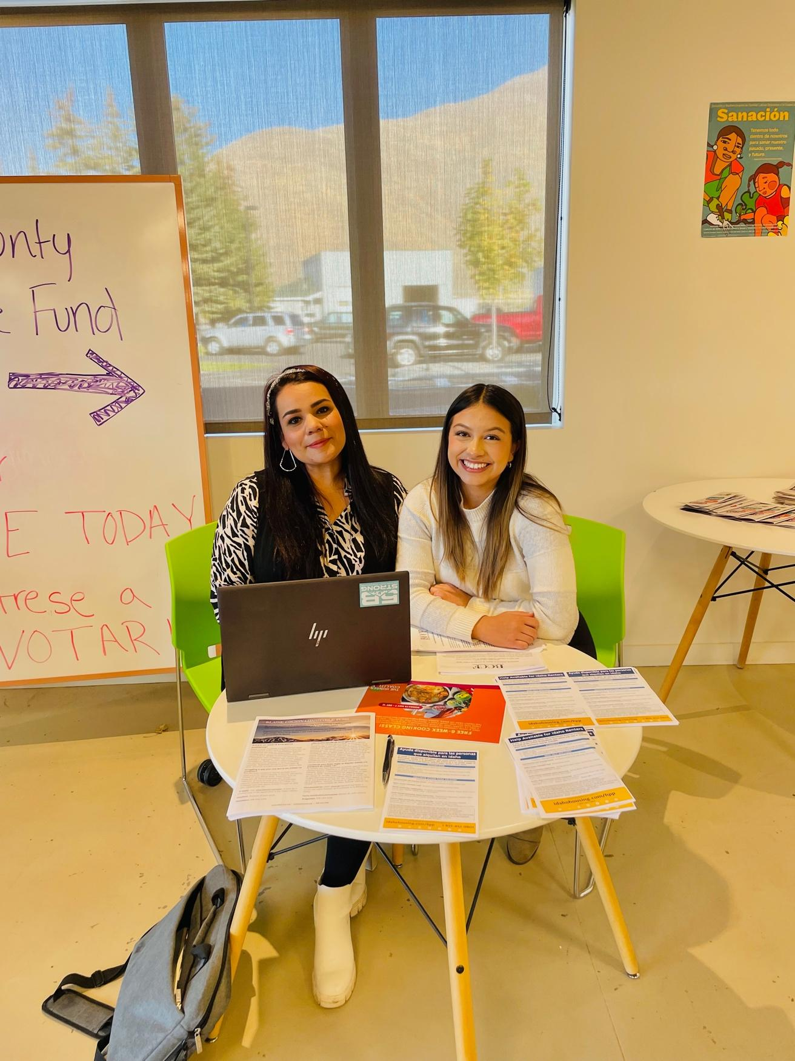
Bilingual Family Care Coordinators Siomara Navarrete and Elizabeth Sandoval meet people in their moments of need by providing bi-monthly outreach at the Hunger Coalition’s food distribution.

BCCF Staff: With new offices in the formally known Marketron Building, BCCF offers in-person office hours five days a week with their Bilingual Family Care Coordinators.

