LEE PESKY LEARNING CENTGER 2021 Extension Final Report
Pathway to Literacy (rebranded as Lee Pesky Literacy Pods)
Grant Amount: $25,000

Grant Program in Review

Lee Pesky Literacy Pods strive to eliminate the educational opportunity gap often experienced by students from culturally or linguistically diverse backgrounds whose learning challenges can go undetected and untreated. Previously called Pathway to Literacy, we have rebranded the program as Lee Pesky Literacy Pods, establishing this once nascent program as a traditional arm of the work of Lee Pesky Learning Center and integrating it into the fabric of our daily services. This wraparound program provides summer instruction to dozens of students, many of whom are offered continued support during the academic year and one-sixth of whom may be referred “by us to us” for further evaluation for possible learning disabilities. By working with these students for one year, we are better able to separate the challenges of learning a new language from the challenges that may signal a learning disability, while simultaneously providing more families with specialized intervention.

Objectives & Outcomes

STUDENTS
Our summer program served 30 students; 28 of whom completed the entire program. Each student received 30 minutes of 1:1 reading instruction, four days per week, for five weeks. Eighty-six percent of the students served through the Literacy Pods program were English learners. The remaining four students were fluent English speakers but identified as needing significant reading intervention. Students served included 1 rising kindergartener and 27 rising first and second graders. Our program was part of Blaine County School District’s Summer Bridge Academic Camp provided at Bellevue Elementary. Other partners included the local YMCA, the I Have a Dream Foundation, and the College of Idaho. Summer outcomes are reflected in the table below.

Student Reading Gains

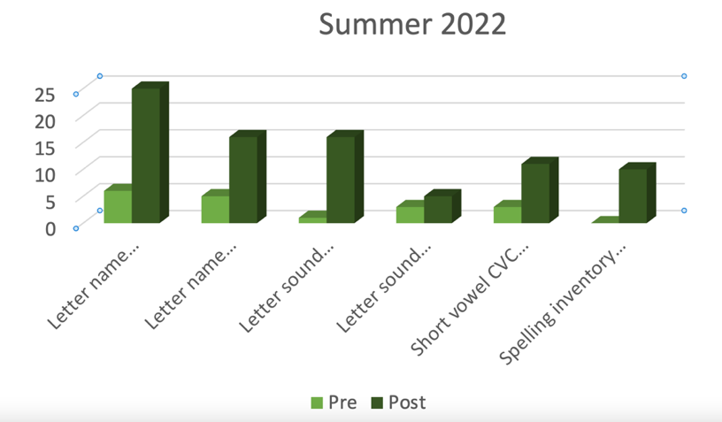

Our academic year program served six of the students identified as needing additional help after the summer program concluded. Only three of these six students completed the entire academic year program, and their gains are reflected in the table below.

Student Reading Gains - Academic Year, 2022-2023

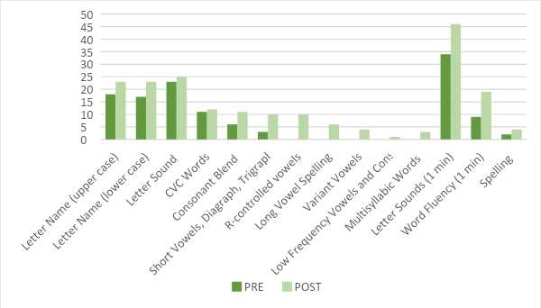

PARENTS AND COMMUNITY
An end of summer school celebration was held at Bellevue Elementary at the conclusion of our programming. We distributed 75 literacy learning mats in Spanish and in English and had a brief presentation by our native Spanish speaking co-
director. We also joined the Wood River YMCA in March 2023 to present at a parenting class held in Ketchum, ID. This presentation was delivered in Spanish and literacy materials were distributed.

Photos – See below.

Budget

Expenses | Amount requested from WRWCF | Actual Expenditures
Personnel | 23,800.00 | 17,241.56
Resources & Materials | 600.00 | 2,795.74
Program Supplies & Events | 600.00 | 1,064.50
Travel & Lodging* | 0.00 | 3,898.20
TOTAL | 25,000.00 | 25,000.00
*Travel to and from Bellevue/Hailey and lodging as needed.

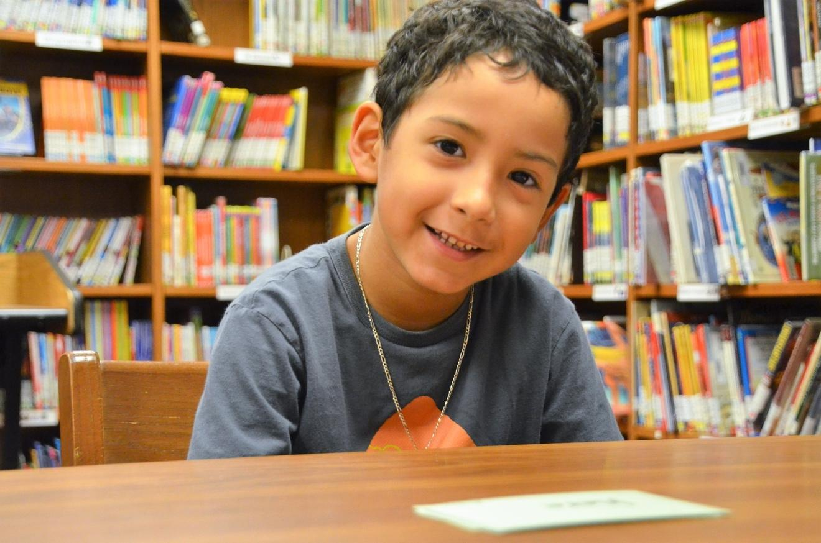

A Lee Pesky Literacy Pods student reads his flashcards.

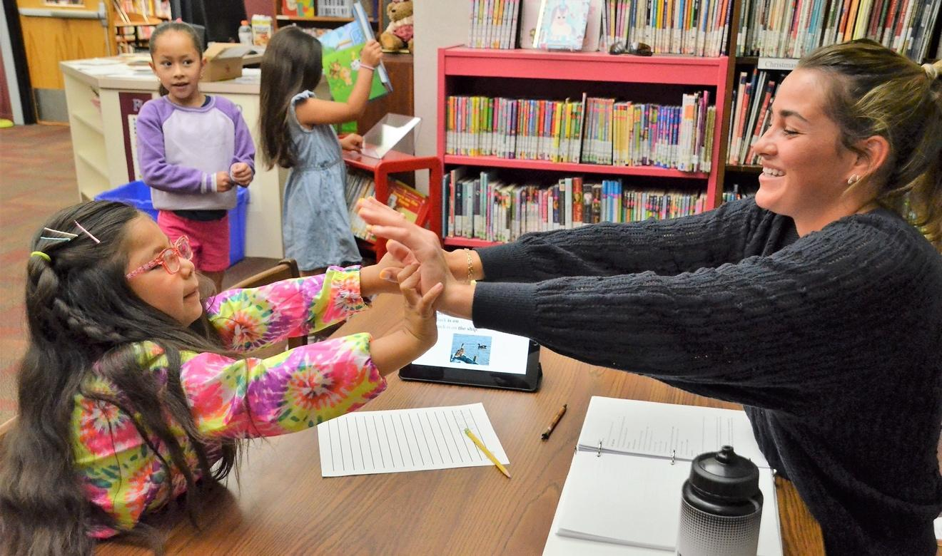

: A Lee Pesky Literacy Pods student receives praise from her tutor.

