GIRLS ON THE RUN SOUTHERN IDAHO 2021 Extension Final Report
Blaine County Programming for 3rd-8th Grade Girls
Grant Amount: $9,940

Grant Program in Review

As a part of our curriculum each GOTR site creates and implements a Community Impact project. When we teach our youth the value of community service, everyone benefits. Children with giving hearts are more likely to think empathetically and treat others with respect. This fall one site created posters and signs with positive, uplifting messages and artwork then posted them all around their school and on every staff member's door. When the school staff came to work the next day they were greeted with signs that said BeYOUtiful, Have the BEST day, GOTR Loves You, and many more. Later, one of the teachers informed GOTR that all of the school staff were so happy all day and wanted to incorporate the positive messages into their school culture. This small, yet significant Community Impact project taught our girls how a small act of kindness can change the world.

Objectives & Outcomes

During the 2021 Fall season we served girls in grades 3rd-5th and hosted five sites in the Wood River Valley with 55 girls. These girls were supported by 12 coaches. Our 2022 Fall season we hosted three sites, served 52 girls in grades 3rd-5th. These girls were supported by 10 regular coaches and 1 Junior Coach. Eight of these coaches were new in the 2022 Fall season. Each season girls completed a community impact project at each site and a season ending, celebratory 5k with all of the sites combined at Swiftsure Ranch.

Based on postseason parent surveys, over 70% stated that their child was more confident. Even more impressive is that a participant's post season survey was the important lessons that were covered and instilled at practice. Answers included, to keep going and I can do anything, to be honest and kind, if you try hard enough you can do it, and I am strong and loving and helpful to others.

Photos (See Below)

4) Budget

Expenses | Amount Requested from WRWF | Actual Expenditures
Salary | $4,800 | $4,800
Occupancy/Rent/Office Expenses | $587 | $1,289
Training/Professional Development | $832 | $800
Insurance | $384 | $623
Equipment | $160 | $100
Supplies/Curriculum | $768 | $228
Print/Copying/Postage | $280 | $20
Licensing | $1,091 | $1,100
Marketing | $274 | $466
Background Checks/CPR Certification | $57 | $14
Volunteer Appreciation | $320 | $113
Administration | $387 | $387
Total | $9,940 | $9,940

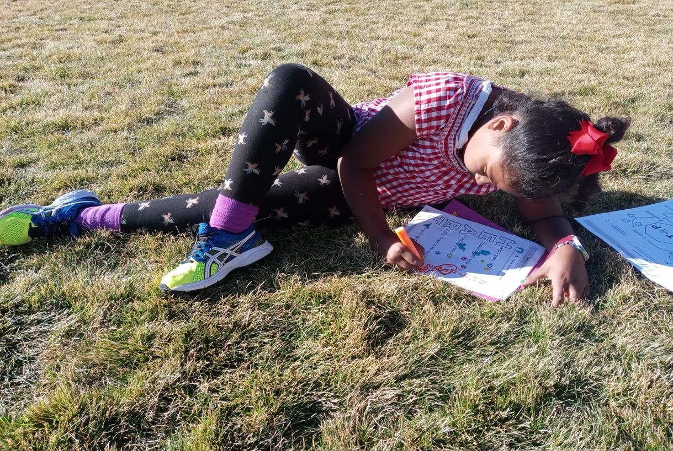Photo Journaling: At the end of each practice as a part of our lesson debrief, the girls journal about what they learned and about their running goals and progress for the day.

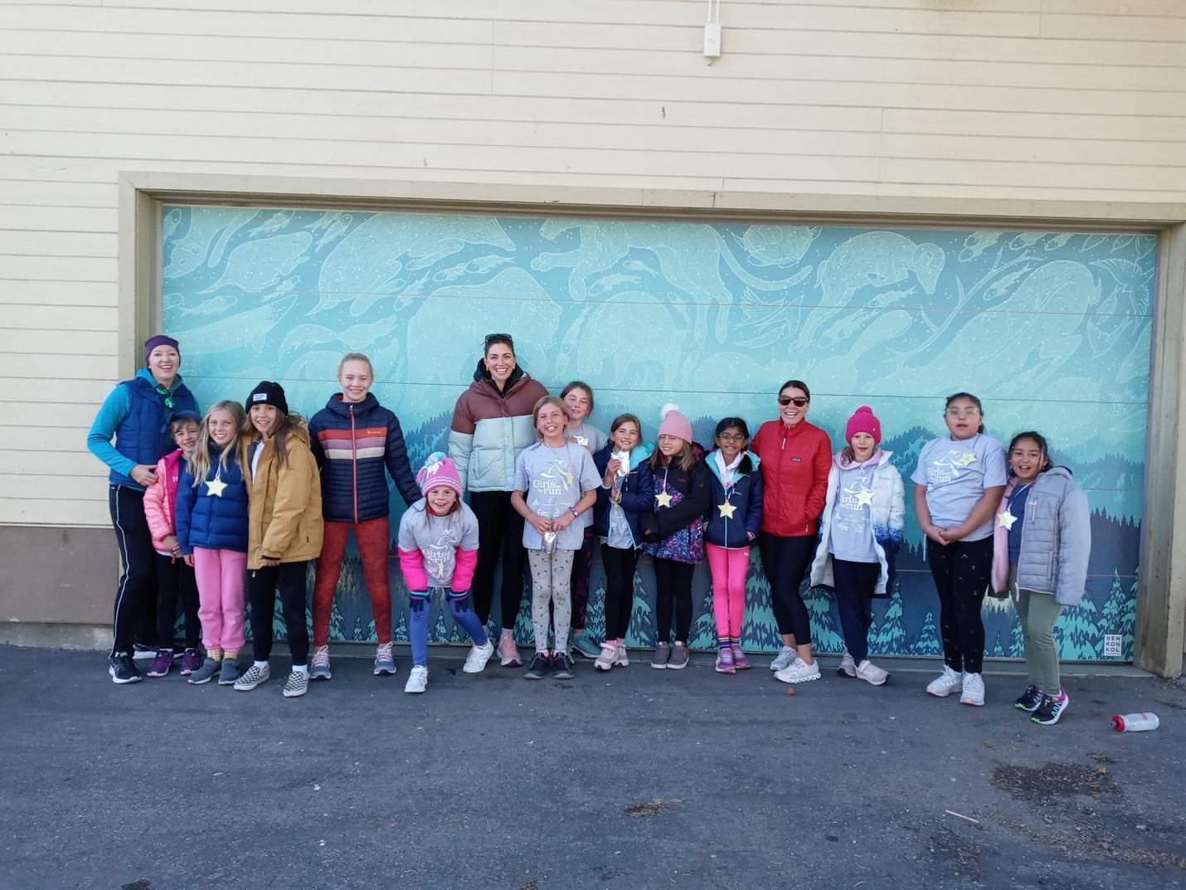Photo Practice 5k: Each team does a practice 5k with their team before the culminating event. This shows the girls they can do it before the big event.

