WOOD RIVER COMMUNITY YMCA 2021 Final Report
Grant Title: Power Scholars Academy Camp
Grant Amount: $25,000

Year in Review
This summer the Y hosted 60 scholars comprising rising 2nd and 3rd graders from all five Blaine County elementary schools. The theme for the summer was local pollinators. Scholars were encouraged to think like scientists to explore the world of native plants and species. They collected information and made observations to devise methods to support our local pollinators. The Y partnered with the Wood River Weekly newspaper so the scholars could share their findings by publishing an insert in the newspaper. The scholars invited their parents and community partners to a Readers Theatre to share more about what they learned. One mother shared that her son would never pick up a book just to read. Part way through the program her son began grabbing books to read to them. That interest has carried on through the school year and he is now a leisure reader no longer presenting a challenge at home.
Objectives & Outcomes
Students nominated for this program could normally see a summer slide of up to 3 months. The Y utilized pre- and post-testing to track outcomes. Data showed scholars maintained their academics instead of a 3-month loss of literacy and math skill. A recent report from the Center for School and Student Success showed that student gains over the course of the school year were at a lower rate compared to pre-pandemic trends. We can assume that lower academic gains throughout the course of an entire year can also translate to summer growth. With a five-week program and students making academic gains at a decreased rate, maintaining these levels is a real success. Our teacher and parent survey showed 89% of scholars increased their readiness to learn and their ability to work through challenges. Additionally, 100% of parents were highly satisfied with the program.

Photos

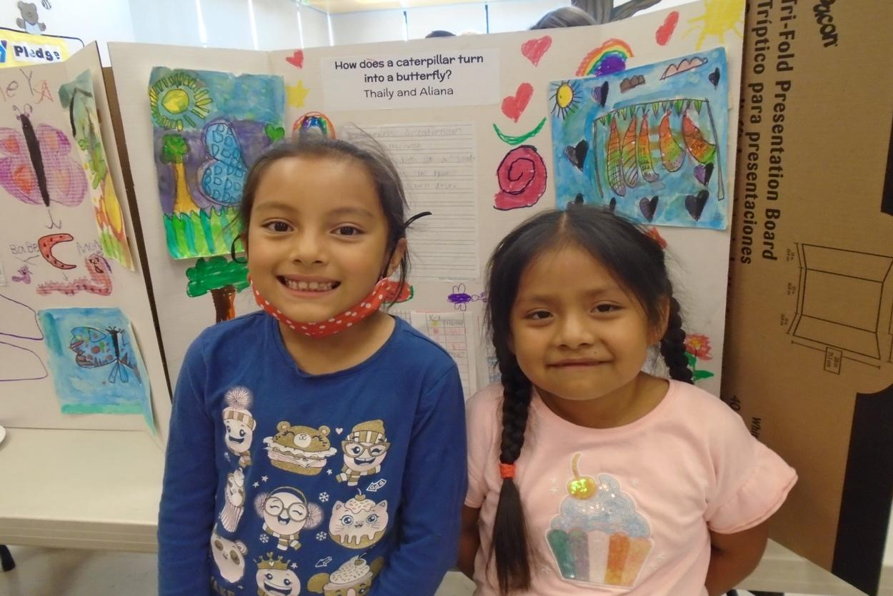
Scholars pose by their original work that was published in the Wood River Weekly.

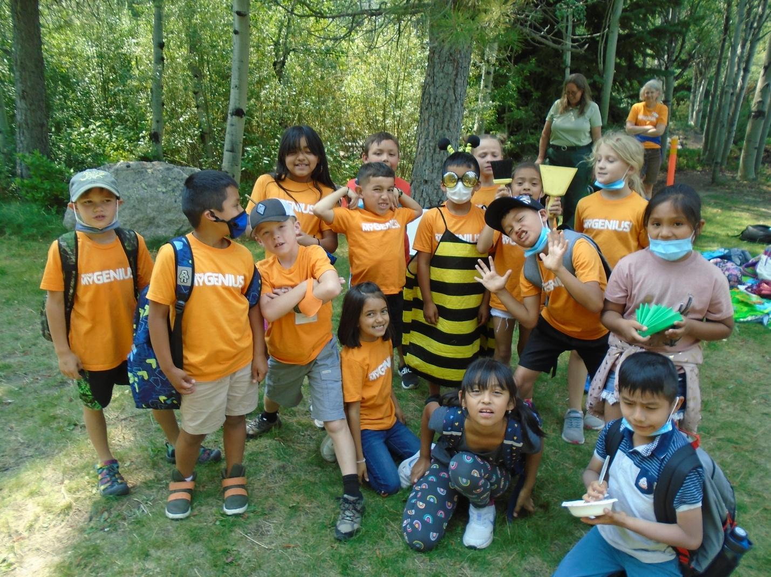
Scholars on a field trip at the SNRA where they learned about all the jobs that bees have in a colony.

Budget
Expenses | Total Expenses | Actual
Salary and Benefits | $62,460 | $52,333
*Occupancy (rent, utilities, maintenance) *BCSD offsets this line with an in-kind donation. | $13,000 | $13,000
Training & Professional Development | $3,500 | $3,500
Contract Services (evaluation, technical assistance, consulting, professional, fundraising) | $8,000 | $8,000
Supplies (curriculum, program and project supply, scholar meals) | $30,000 | $18,952
Travel (field trips) | $3,000 | $2,500
Printing, Copying & Postage | $1,000 | $1,000
Marketing | $500 | $500
Administration | $25,000 | $25,000
Total Expenses | $146,460 | $124,785.00
Prior to the program, Blaine County School District agreed to pay any staff we hired who are currently employed as a certified teacher. This decreased the Y’s salary and benefits expenses.

