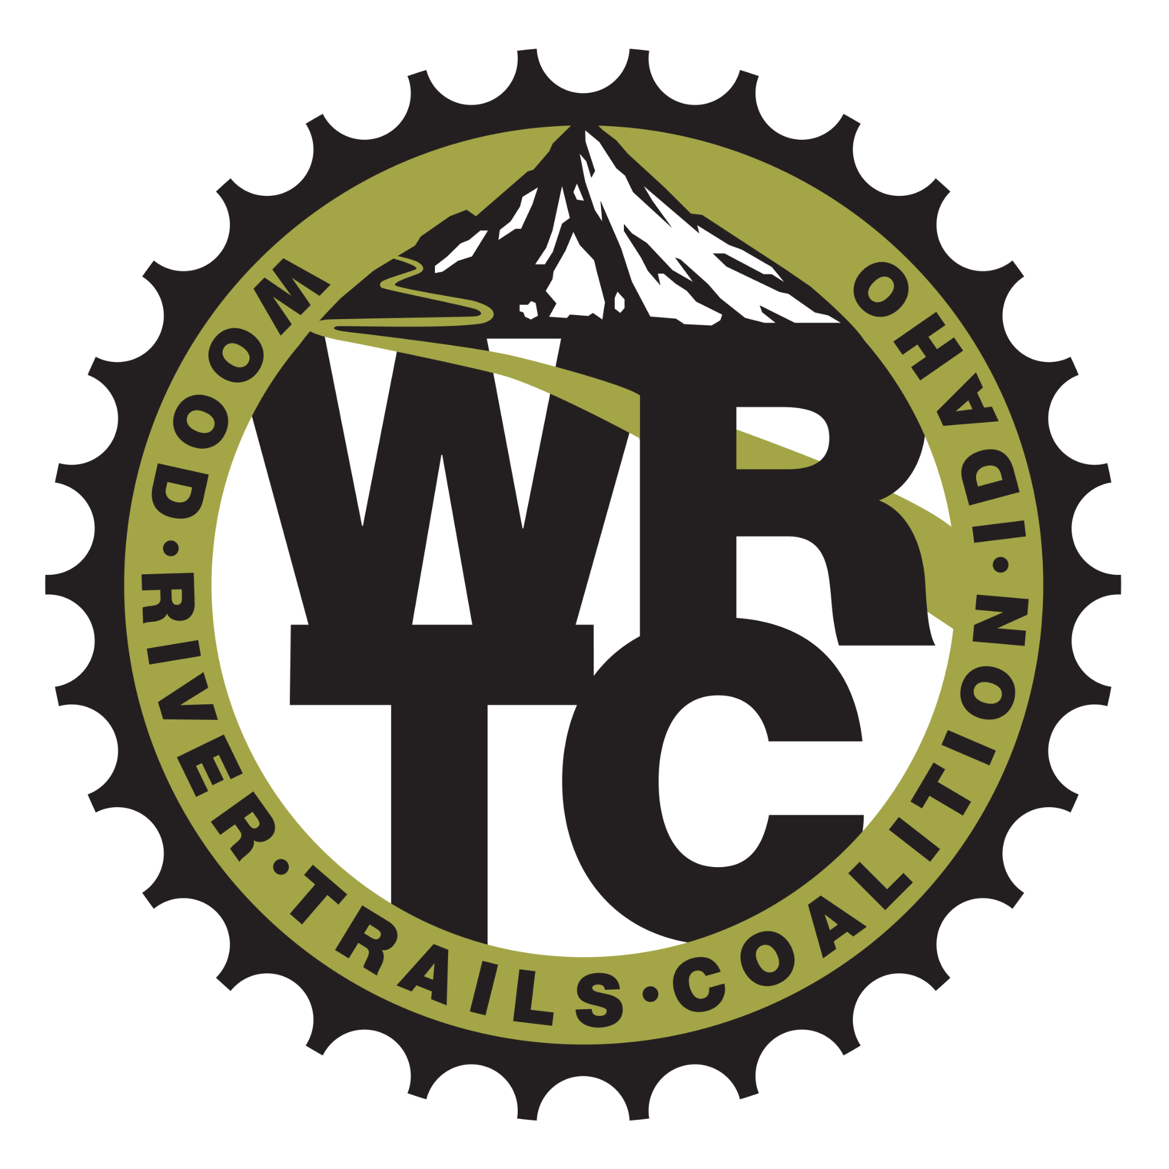

Wood River Trails Coalition 2021 Final Report
Grant Title: Trail Boss Program
Grant Amount: $22,460

Year in Review

The biggest impact of our Trail Boss program is the opportunity to engage with passionate, motivated volunteers who we trust to help carry out our mission, be our ambassadors and expand our capacity. They are super volunteers who go above and beyond in ways other than just trail work, such as helping upgrade our technology, expanding our trail knowledge and networking with segments of our community we might not otherwise.

The Trail Boss program is now in its second year. We had all seven Trail Bosses return from 2021, which is a remarkable achievement. A few weeks ago, on June 4th, we had 59 volunteers, a record, come to a trail work party out Adam’s Gulch. The Trail Bosses took small groups and worked without WRTC staff supervision, allowing us to get more done with a very large group of volunteers. Without the Trail Bosses, this would not have been possible.

Objectives & Outcomes

- Objective: We wanted to train eight Trail Bosses every year who would each assist with three volunteer events a summer. We wanted a 65% retention rate from year to year for our Trail Bosses.
  - Outcome: We trained seven Trail Bosses in 2021 and seven returned in 2022 for 100% retention rate. They all helped with at least three volunteer events.
- Objective: We wanted a 40% volunteer retention rate for 2020/2021, with 200 total volunteers.
  - Outcome: We had 212 total volunteers in 2021 with a 58% retention rate from 2020 to 2021.

- Objective: We wanted 908 total volunteer hours in 2021.
  - Outcome: We completed 879 general volunteer hours in 2021 plus 180 of Trail Boss hours for a total of 1,059 hours. We did this with fourteen general volunteer events and four Trail Boss workdays that resulted in 29 miles of trail maintained, 38,300 feet of tread work, 97 drains cleaned, 42 berms raked, 187 logs cleared, 10,500 feet of trail brush and 18 drains built. This is an increase in work numbers from 2020, due in part to our Trail Bosses helping at events and Trail Boss only workdays.

Photos

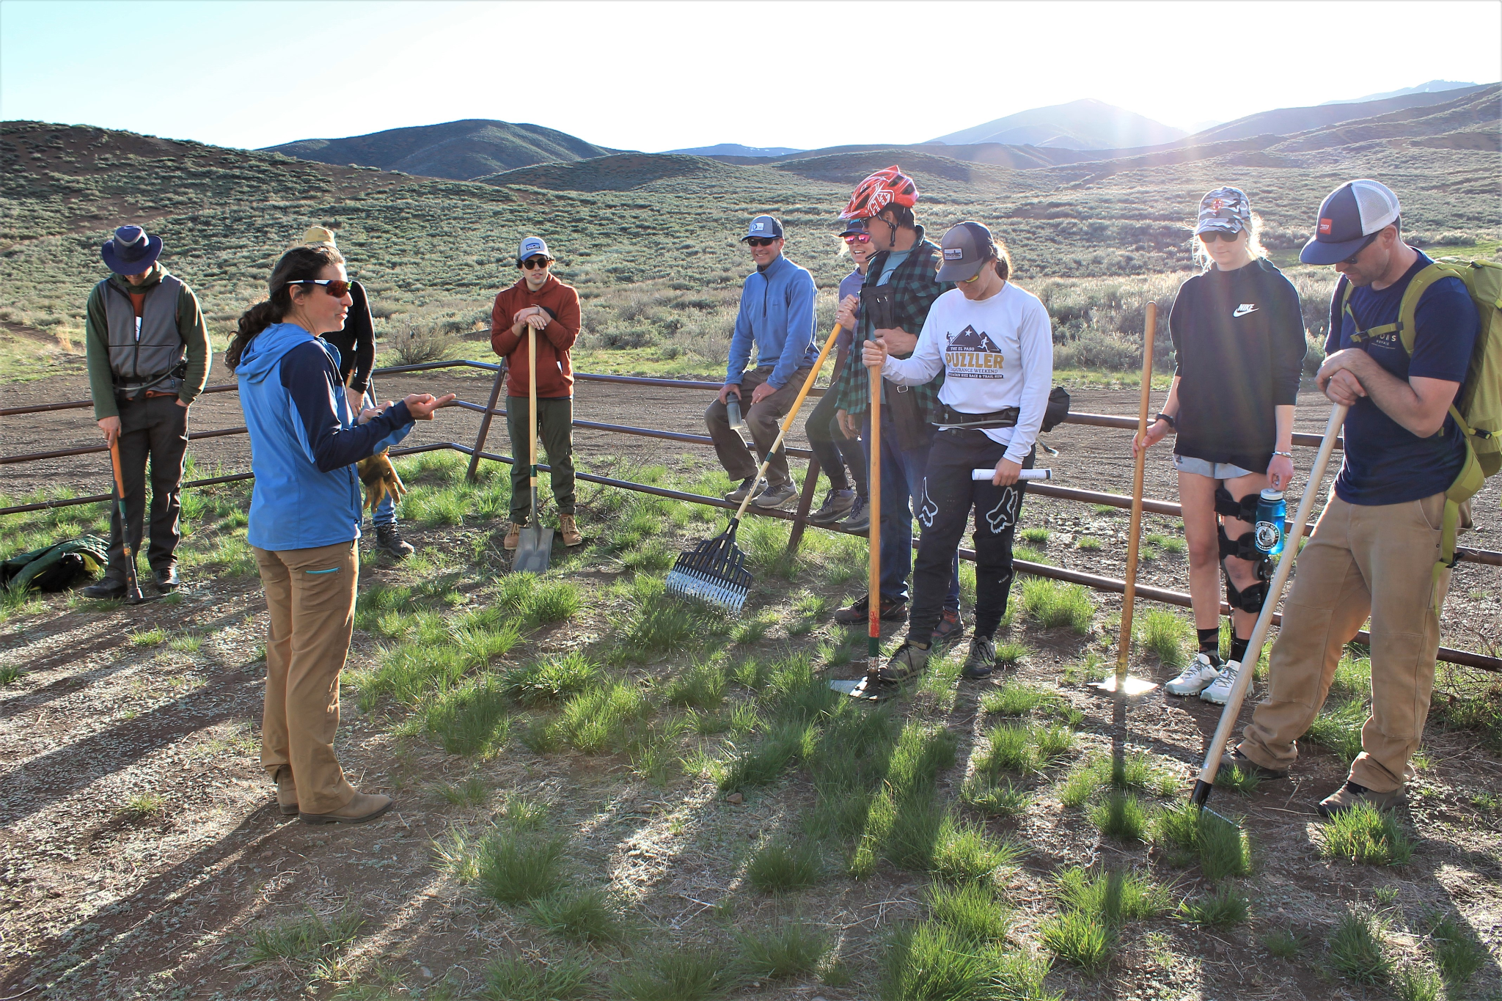
Trail Boss Training Session One at the Croy Trails. Kya Goldschlager and Trail Bosses going over different tools and their uses, May 2021.

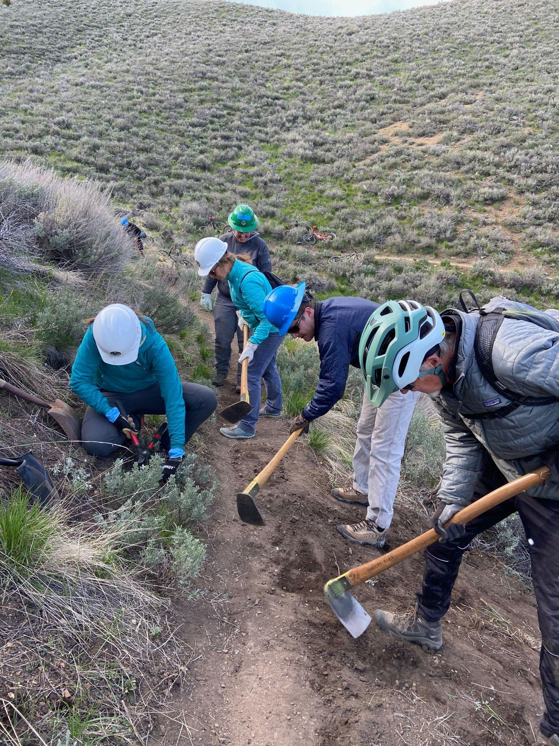
Trail Boss Conner Madigan (blue hard hat) leads a group of volunteers at a work party on the Hidden Valley Trail, May 20th, 2022.

Budget

Expenses | Amount requested from WRWCF | Actual Expenditures
Wages for Volunteer Coordinator | 13,440 | 13,497
Tools & Equipment | 2,000 | 2,215
Gas | 900 | 958
Volunteer Food, Gear & Uniforms | 1,500 | 1,396
ED Wages for Support of Program | 4620 | 4,841
Vehicle Maintenance | 0 | 120
Staff Training | 0 | 220
Insurance (GL, Auto & Trailer, Worker’s Comp) | 0 | 10,091
TOTAL | 22,460 | 33,338

Our insurance costs took a large jump in 2021 because of additional personnel on our payroll, which increased our worker’s compensation insurance substantially. We also increased our General Liability limits since we are a bigger organization with more volunteers. So, these costs associated with the Trail Boss program (which we did not ask WRWF for funding to cover) obviously cover more than just the Trail Boss program, but they are essential to operating our overall volunteer and Trail Boss programs so that is why those costs are included here as overall program costs. We did keep our spending very close to what we requested; our total in the categories above for WRWF funding totaled to $22,907, compared to $22,460 requested, with our overall project costing $33,338, compared to the $33,370 estimated in our initial grant application.

