SWIFTSURE RANCH THERAPEUTIC EQUESTRIAN CENTER INC. 2021 Final Report
Grant Title: Arena Footing for Main Arena
Grant Amount: $15,664

Year in Review
The impact of this grant is that the working surface for our main arena, where a large proportion of our activities take place, has been replenished and will now safely and comfortably support years of equine assisted activities, benefiting all our participants, our horses, and our volunteers. Without this essential periodic maintenance, the arena surface – which is the literal foundation of most of our programs - would degrade over time, becoming harder and more uneven, risking injury to horses and volunteers, and compromising overall program safety.

Objectives & Outcomes: All measurable objectives were achieved.
a. Successfully achieved a comfortable, consistent, safe working surface in the main arena, with a measured depth of over 4 inches of soft materials over the underlying substrate.
b. Successfully achieved a working surface that will enable us to conduct regular weekly activities in our main arena for years to come. The main arena enables us to host our participants year-round, in any weather conditions, in a safe and pleasant environment.
c. Successfully achieved a working surface that is ideal for our working horses, protecting them from injuries due to slippery conditions or repetitive work on hard or uneven surfaces.
d. Successfully achieved a working surface that is level and safe for our volunteers, enabling them to give their full attention to our riders.

Photos (see before-and-after photos below)

Budget
Expenses | Amount requested from WRWCF | Actual Expenditures
Fiber footing, delivered | $6448.00 | $6448.00
Sand footing, delivered | $9216.00 | $9216.00
TOTAL | $15,664.00 | $15,664.00

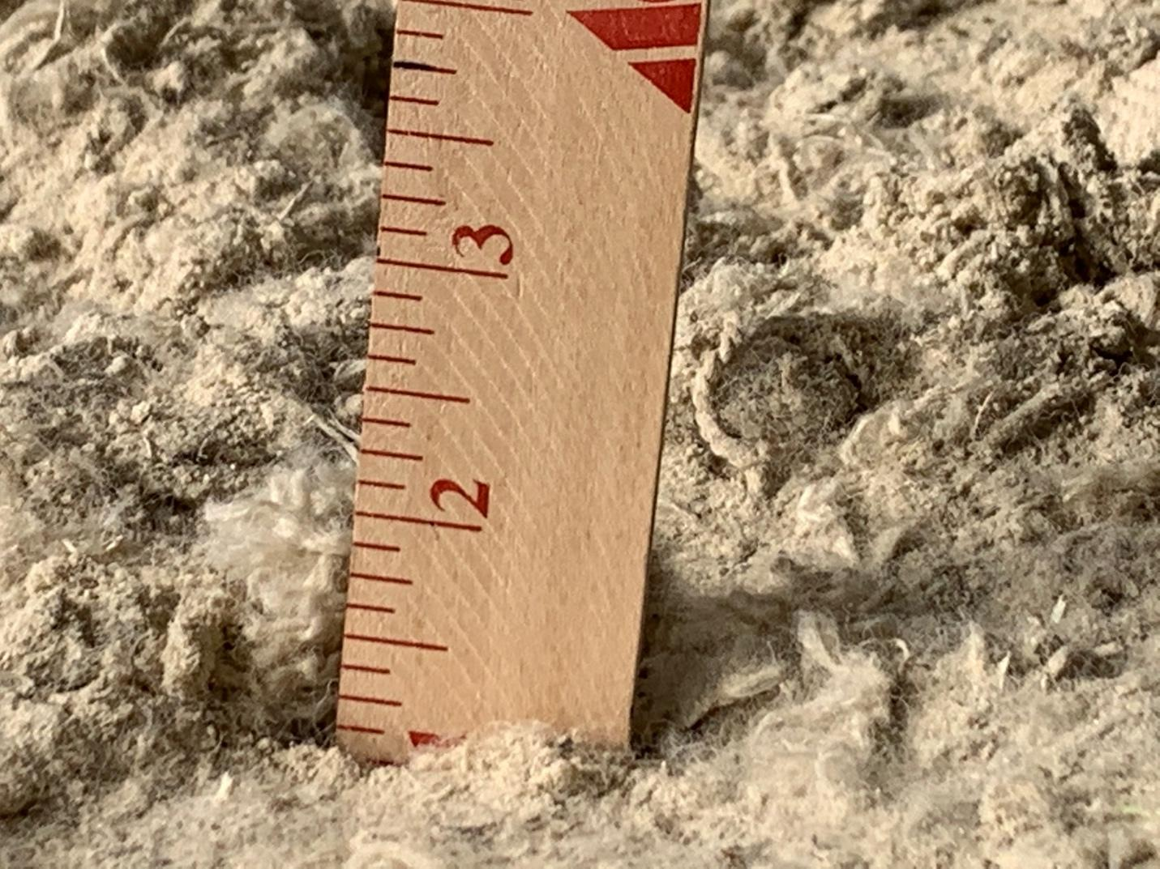

Before: The footing should be 3 - 4 inches deep but had depleted to 1 inch due to normal use over several years.

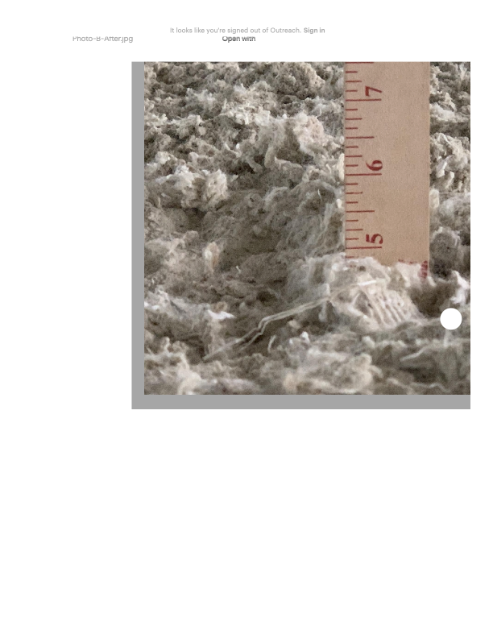 After: The replenished footing is now 4-5 inches deep and offers excellent protection to the arena surface, our riders, our horses, and our volunteers for years to come.

