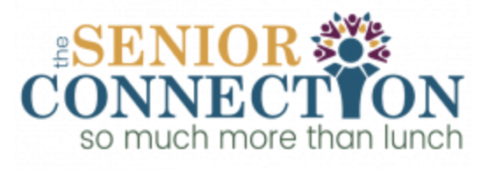

THE SENIOR CONNECTION 2021 Final Report
Grant Title: New Bus for Senior Transportation
Grant Amount: $15,228

Year in Review

Your investment in a new bus for the Senior Connection will go the distance in providing a safe environment for our seniors to enjoy socialization and physical activity, forcing the brain to be active and engaged. According to the CDC’s Alzheimer’s Disease and Healthy Aging Program, loneliness and social isolation put older adults at risk for dementia and other serious medical conditions. Your generosity offers essential support for Seniors who otherwise can’t get out into the fresh air and enjoy friendship and a sense of independence. Although we have yet to procure the new bus, we are working hard to navigate higher costs and supply chain issues to obtain this new mode of transportation as soon as possible and anticipate the vehicle on site by year end. We are incredibly grateful for your support of $15,228.

Objectives | Outcomes (Transportation Program)
Improve mobility for Blaine County Seniors | We are the only service who provides door to door transportation in Blaine County. In the last year, we’ve provided over 1,000 rides to and from the Senior Connection and to community events.
Ensure community and personal safety | On average, seniors outlive their ability to drive by 7-10 years. For over 1,000 rides in the last year, we’ve worked hard to keep our seniors and roads safe while providing comradery and physical activity.
Keep older adults connected to the community | Despite COVID keeping closed 12/27/21-3/6/22, we’re thrilled to be resuming our Let’s Get Out summer adventure series as well as offering the opportunity to attend multiple community events including concerts, community festivals, and monthly field trips out into nature.
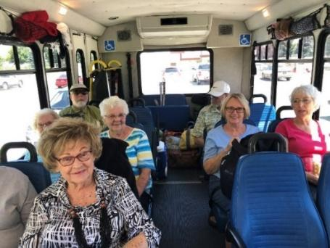
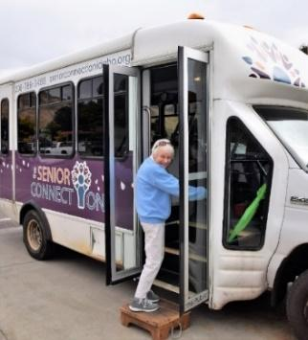
Photos

Budget
During our November Application for 2021 Funding, the quote for a new bus was $63,840. Your incredibly generous investment of $15,228 along with the initial funding we had secured from Idaho Transportation Department prepared us for the procurement of the vehicle. To no surprise, due to supply chain issues, the cost of the vehicle has significantly increased to $101,583, a 59% increase from the original quote. Despite this increase, we’re still procuring the vehicle. We’re accessing our long term/emergency reserve fund to cover the costs and will apply to Idaho Transportation Department this coming Fall with the hope that we will be reimbursed for the increase in cost. We’ve set your generous investment aside in a separate fund at Edward Jones and are retaining these funds for the purpose of the final purchase of the vehicle.

Expenses | Amount requested from WRWF | Actual Expenditures to be incurred
Vehicle Cost | $12,768 | $101,583
Branded Bus Wrap | $2,500 | $2,500
TOTAL | $15,268 | $104,083

