LITTLE WOOD RIVER DISTRICT LIBRARY 2021 Final Report
Grant Title: Flagstone Area
Grant amount: $10,000.00

Year in Review

I have seen children and adults reading, playing, and doing crafts in conjunction with our library programs, and as family activities. We are located across the access road from the grade school and high school, making it a place that parents can wait for their children, or students can wait for events. Because it is sheltered from the street, and view, it is a safe place for children and adults. I have seen an unusable space turned into a safe and inviting place for all our community.

Our public library had a very unusable outdoor area, nice and shady and large enough that it could be used for summer reading, family gatherings, or just as a place to spend time with friends. However, this area was weed covered, with dirt and gravel covering the ground, making it unusable. Putting grass in to cover this area would have been a financial burden, needing someone to mow and water and general upkeep. Now with the donated flagstone, and the grant money to install it, it is a maintenance free, level place to enjoy. With picnic tables for adults and children, and 24/7 internet it can be used to study or just have fun. It is used for all the community whether the library is open or not. In all, it is a real asset to our library and our community.

Photos (see below)

Budget

Expenses | Amount requested | Actual expenditures
Labor | $7,200.00 | $7,200.00
Machine rental | $1,200.00 | $1,200.00
Gravel & road mix | $300.00 | $300.00
Weed Cloth | $1,000.00 | $1,000.00
Picnic Tables | $300.00 | $300.00
Total Amount | $10,000 | $10,000

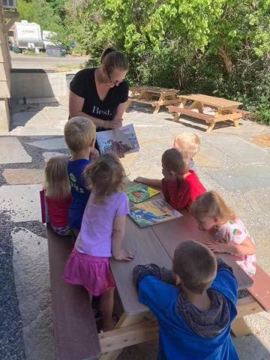
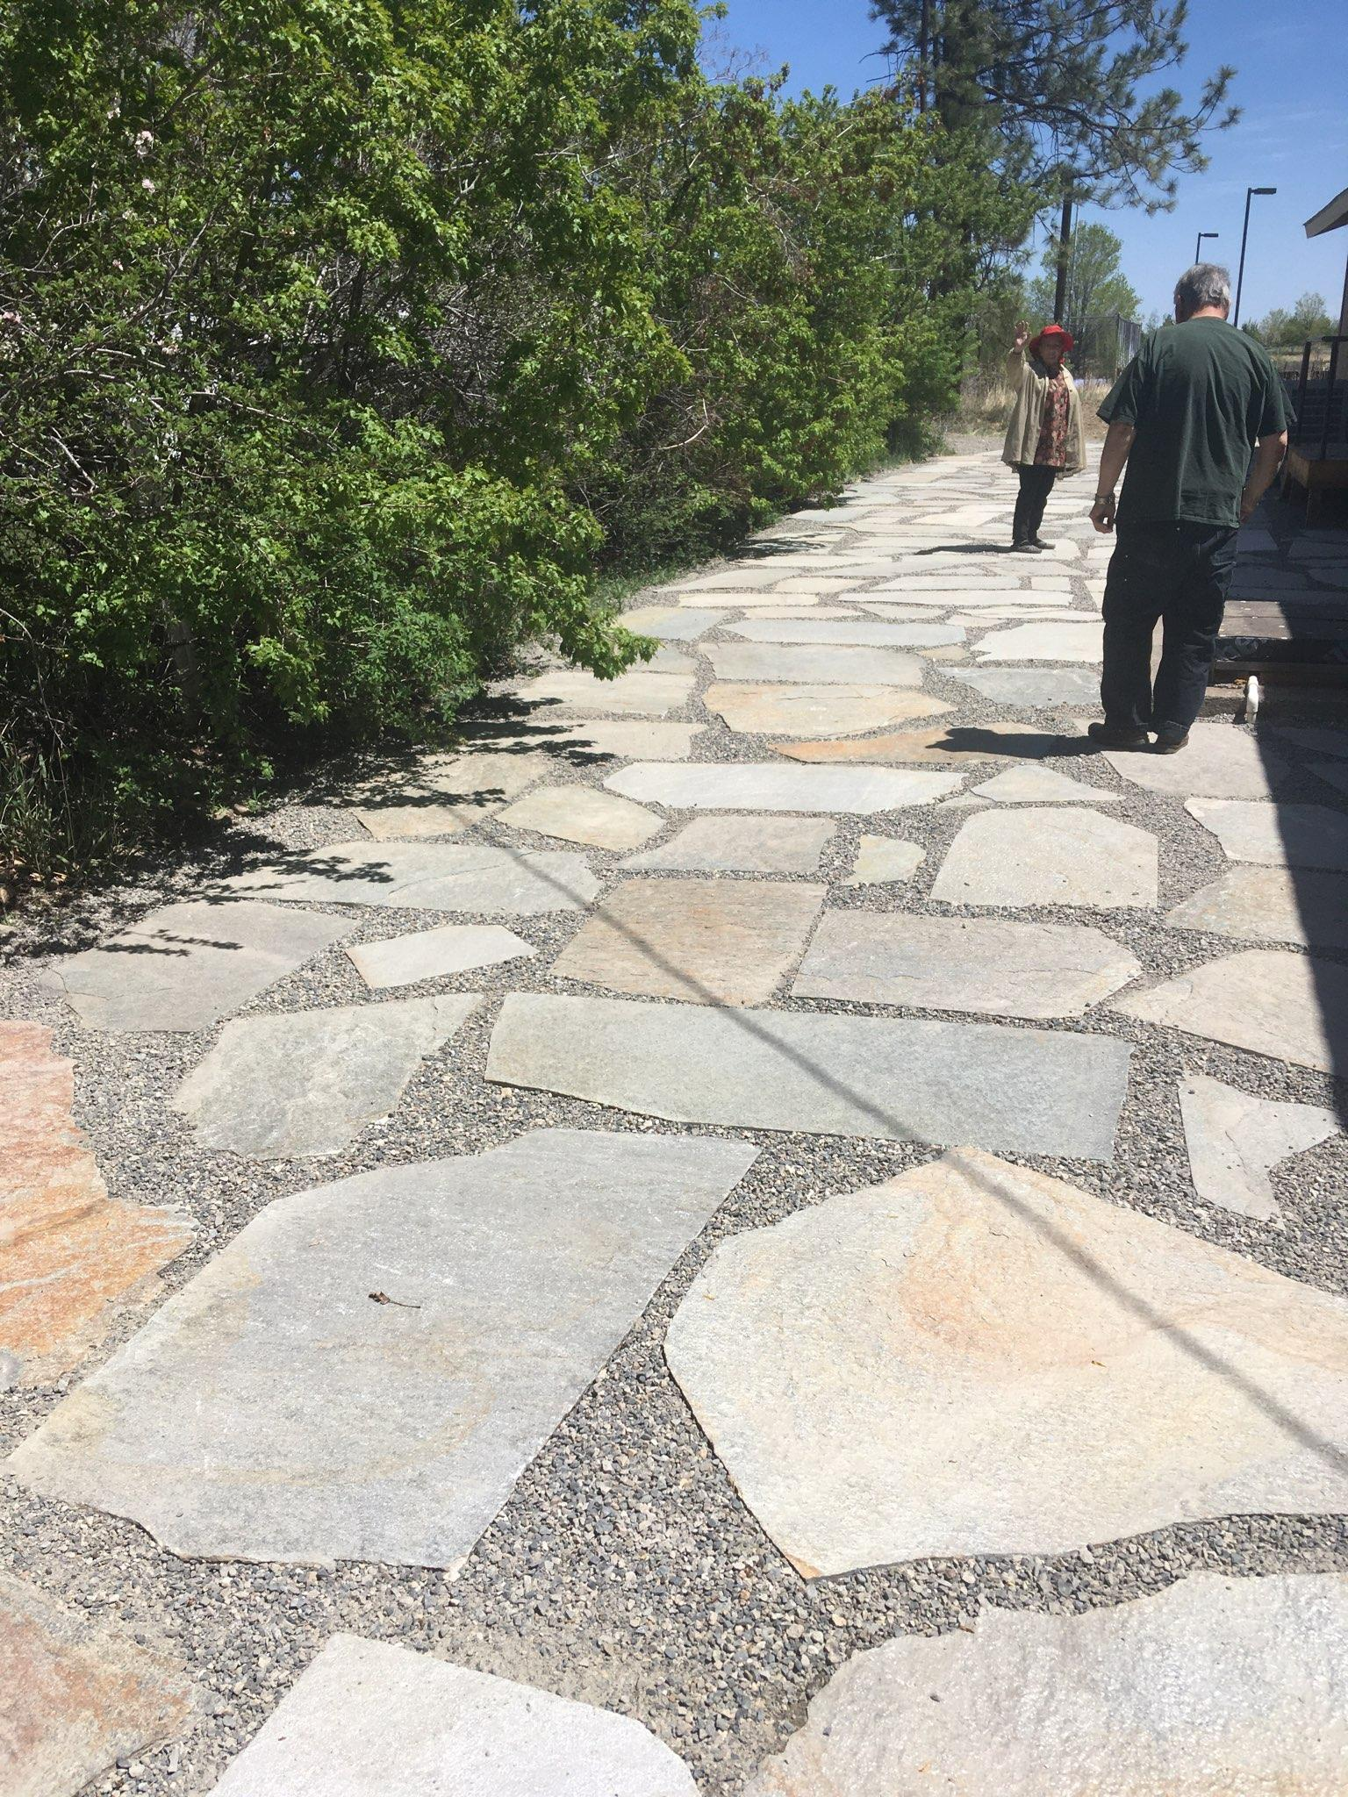

New flagstone area being used by Story Time- New flagstone area just after completion
little children

