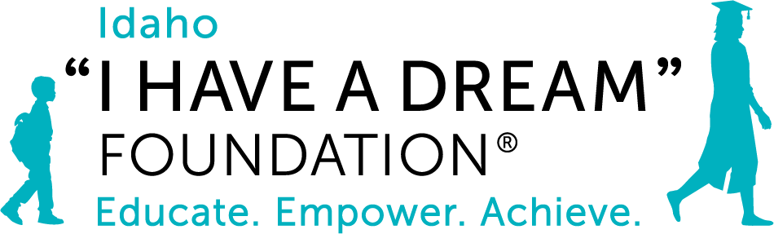

I HAVE A DREAM “FOUNDATION 2021 2021 Final Report
Grant Title: Elementary School Program Expansion (Launch)
Grant Amount: $25,000

Year in Review

Thanks to our WRWF grant of $25,000 and additional funding, we were able to launch our new elementary program last fall to support 40, 1st grade students! Our students arrived in 1st grade behind in all areas due to Covid school closures during kindergarten. We had a highly successful year! We delivered a literacy program that is showing tremendous results and addressed students’ social-emotional learning; Dream Scholar development in both areas has been recognized by teaching staff in the schools we serve. Covid impacted students and staff, but our team worked hard to filled gaps to ensure continued support for our students and families. We learned a great deal regarding student needs and our program design which will inform continued program development. We spent the year getting to know each student so that we can continue to build upon the successes of this past year to support our students’ success.

Objectives & Outcomes

We had tremendous outcomes this first program year with our 40, new Dream Scholars from Hailey, Bellevue, and Alturas Elementary Schools! Our objective is to provide academic and social-emotional learning (SEL) to the students we serve and support our students in all areas of development, so they succeed academically – and we were able to do just that. We introduced a literacy program, and the results were exciting: every single student improved ranging from 2 - 10 levels; our results have been recognized by BCSD teachers. We tracked our students social- emotional development (students were very behind in social development due to Covid school closures); every student has shown significant growth in this area too. Our SEL specialist worked throughout the year to observe and tracked SEL in the following categories: self-regulation, empathy, respect for boundaries, ability to listen, participate successfully in groups and tracked each child’s growth. We’re grateful to WRWF for your support -- we will build on our successes of this first year in academic, SEL and enrichment programs and are excited to see our students continue to develop and gain skills academically and socially, and work toward meeting or exceeding grade level expectations.

Photos (see below)
Budget

Expenses | Amount requested from WRWCF | Actual Expenditures
Salary and Benefits | 25,000 | 25,000
TOTAL | 25,000 | 25,000

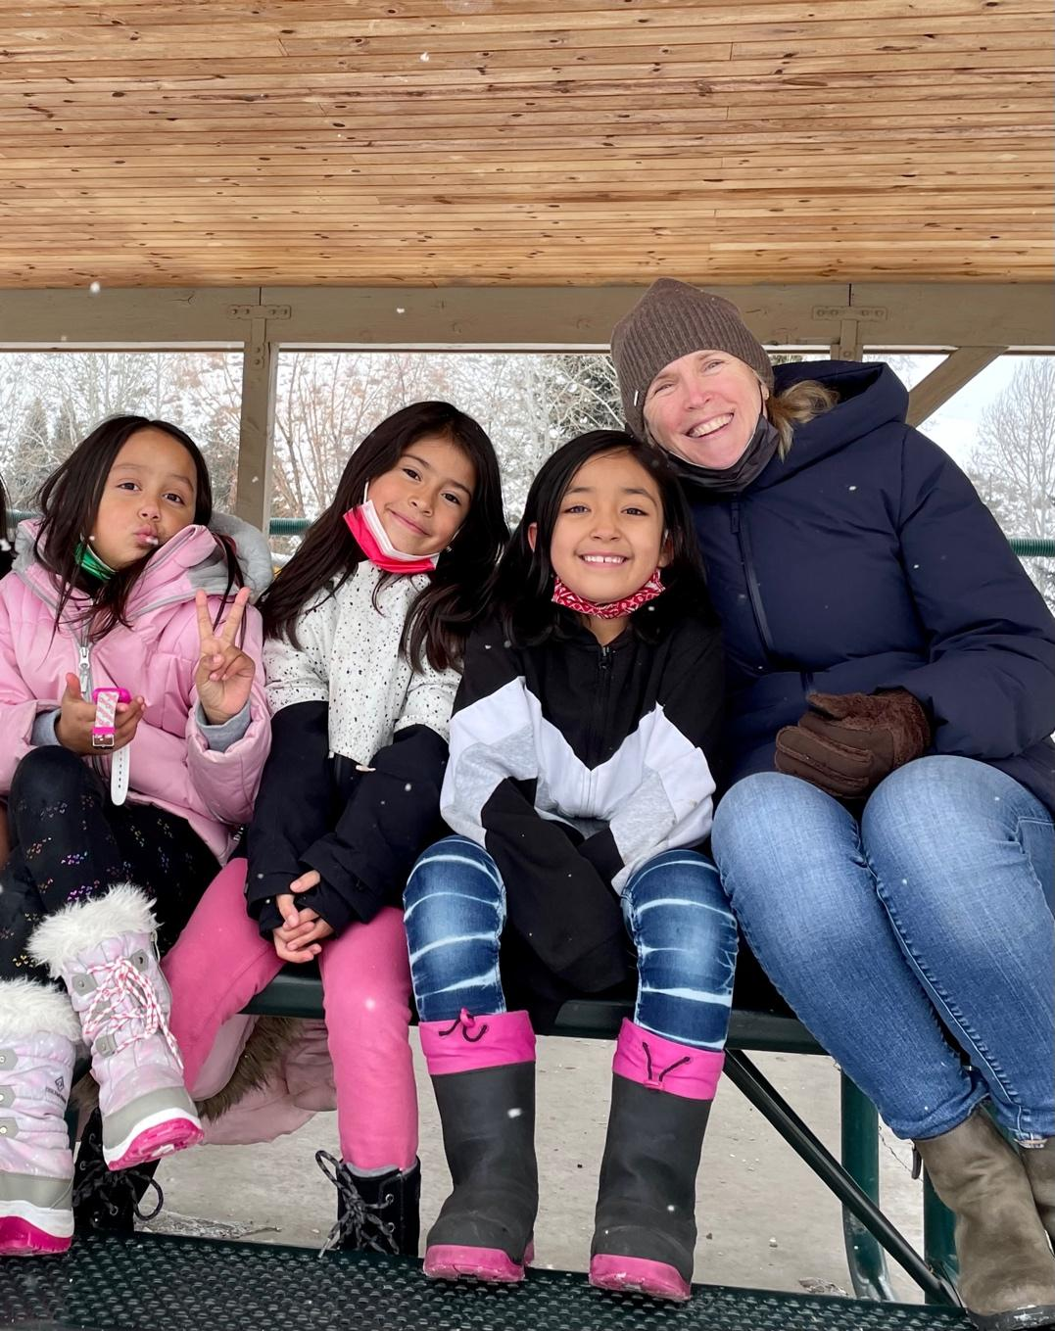
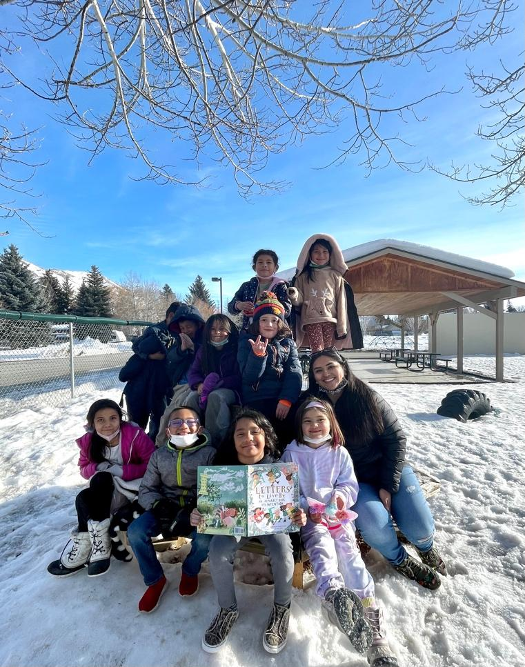
Elementary Students
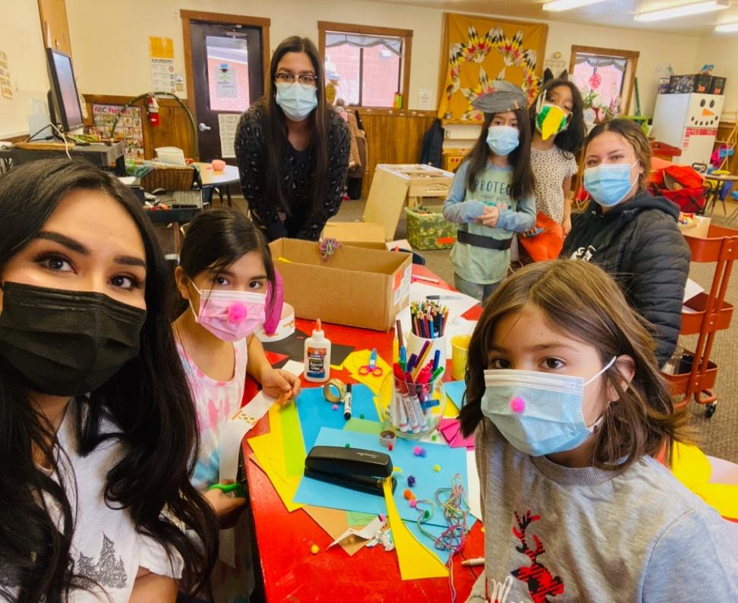

Arts and Crafts with Teen Interns

