HAILEY PUBLIC LIBRARY 2021 Final Report
Grant Title: Expanded Space Initiative (ESI)
Grant Amount: $25,000

Year in Review

The WRWF grant award has been a windfall for the Children's Library at the Hailey Public Library in so many ways. In physical respects, the improvements are apparent with beautiful, functional, versatile furnishings and a new, improved design. The library's cheerful environment and positive vibe are less tangible but just as palpable. The comments from regular patrons, first-time visitors, staff, former staff, and city leaders confirm that the changes have been positive. The WRWF support was an instrumental part of our success.

Our objective has always been to make the youth library welcoming and engaging for children and their families. We scraped and pieced our library together for so long, but the WRWF support validated our work and generated excitement for staff and library users. Knowing that we had flexibility (and money) to deliver on overdue upgrades and dream about the possibilities was motivating, morale-boosting, productive, and highly satisfying.

Objectives & Outcomes

Our objectives were to create a versatile and customizable space in the youth library and increase the library's footprint by utilizing the outdoor for multiple activities to provide an enhanced user experience for programming and services

We first purchased new shelving for the youth library to achieve our goals, focusing on the Spanish language collection. With some retrofitting and a new location, we have noticed a significant uptick in circulation by more Spanish-speaking families. In other collections, the new shelving and age-appropriate-sized seating have families staying longer and finding more books to take home on each visit. As a result, our circulation numbers exceed our pre-pandemic numbers by nearly 15%.

Completing the outside space adjacent to the children's library is equally exciting. Outdoor seating was purchased and a parklet installed to keep children and their caregivers safe from the alley traffic. The cohesive, colorful space features a chessboard created from brick pavers, comfortable seating, and wi-fi. The outdoor space is attractive to kids and adults, but each may use the area in a way that best suits their individual needs.

Last summer, this venue could see upwards of 50 participants at the Wednesday morning Storytime. Already, we host several programs per week in the outside space, but every day we welcome visitors who use the area to study, work, visit with friends, wait for their oil change, or enjoy that small luxury of relaxing with a good book at the Hailey Public Library!

Photos (see below)

Budget

Expenses | Amount requested from WRWCF | Actual Expenditures
Indoor furniture and shelving | 18,000 | 18,000*
Planning/design for furniture acquisition | 1,000 | 1000
Outdoor furnishings & equipment | 6,000 | 6000
TOTAL | 25,000 | 25,000

* Approximately $4,000 was used of the first line item for labor and materials to retrofit an additional space for our tweens which now has a slight separation from the central area of the children's library. The addition helped expand the room and make it much more functional for simultaneous use with children of different ages and needs.

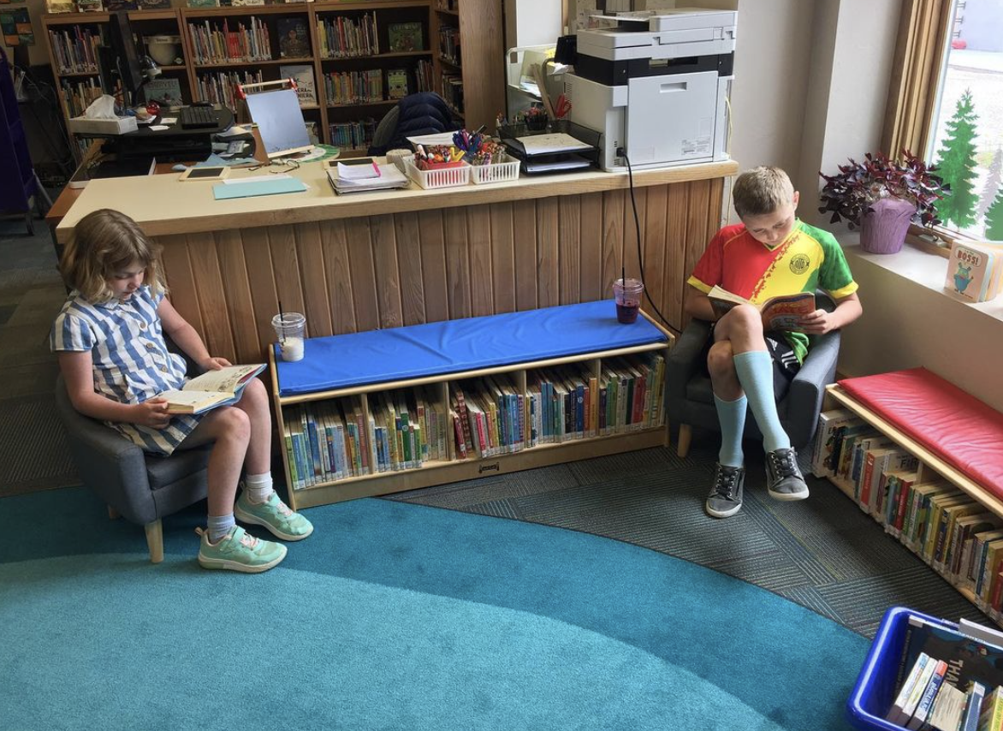
Young patrons enjoy the new kid-size chairs. The small blue & red benches with hidden wheels were also purchased with WRWF grant funds. It doubles as a home for board books and seating for the kids, and they are easily moved when additional space is needed for programming.

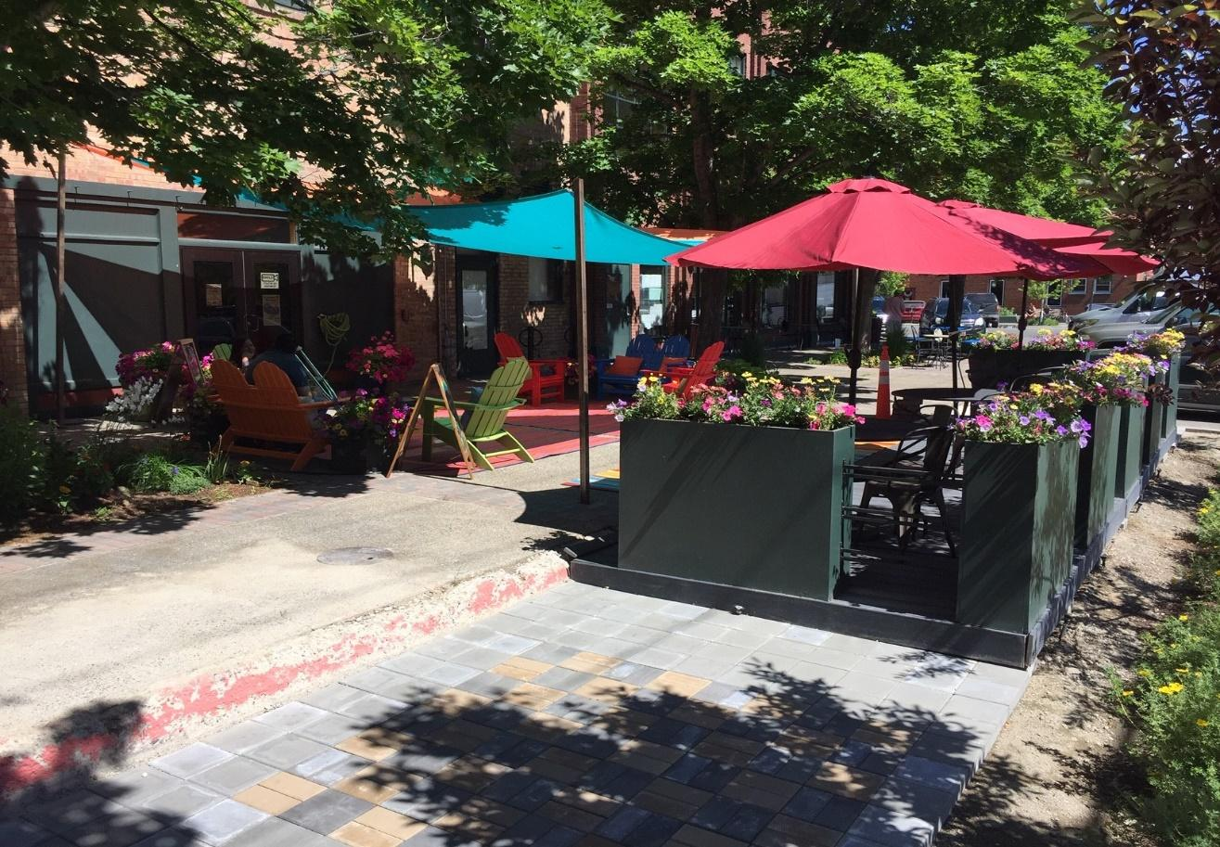
The colorful, comfortable patio area provides a wonderful space for outdoor library programming or suits individual needs for work or pleasure – including a quick game of chess.

