BLAINE COUNTY HOUSING FOUNDATION 2021 Final Report
Grant Title: Housing Gap Grants
Grant Amount: $11,000

Year in Review
The Blaine County Housing Foundation received a $11,000 grant in July of 2021, to provide housing gap grants of up to $500.00 to cover either rent or mortgage costs to those facing housing insecurity. These one-time grants were paid directly to the landlord or mortgage company.
Outcome: The Blaine County Housing Foundation has directly assisted 16 families by paying their landlords, homeowner association fees, and for emergency housing at the Hailey Fairfield Inn. There was a duplication of efforts with the Blaine County Charitable Fund’s programs, so the Housing Foundation changed its focus and now collaborates almost daily with the Blaine County Charitable Fund on use of its emergency funds for housing in Blaine County while we are focusing on the Lift Tower Lodge and qualifying tenants.
In May 2022, the Housing Foundation changed the focus of the WRWF grant to finish a new kitchen at the Lift Tower Lodge to serve residents living in or moving to the 14-room transitional housing motel. These tenants included those being displaced from the J&J Trailer Park.
Objectives & Outcomes
Sixteen families have received approximately $8,000 in WRWF funds through our Gap Grant program. The remaining WRWF funds, approximately $3000, were committed to complete a new kitchen facility at the LIFT Tower Lodge owned by the Blaine County Housing Authority.
- Under the leadership of BCHA Chair and now Interim Executive Director, Sarah Michael, the Lift Tower Lodge was able to expand from 6 rooms to 14 rooms when Ms. Michael approached the City of Ketchum to fix the long-standing sewer connection issue with the city’s $18,000 expenditure. A subsequent grant from the Blaine County Commissioners made many Lift Tower Lodge room upgrades possible so that now all 14 rooms are rented.
- No kitchen or laundry facilities were available.
- The ability to use the WRWP grant to complete the kitchen will have
long term benefits for those who live in this transitional housing facility.
- The Lift Tower provides emergency and transitional housing for
vulnerable members of our community.
http://eyeonsunvalley.com/Story_Reader/9358/Lift-Tower-Lodge-Work- Hopes-to-Provide-Room-for-More/

https://www.mtexpress.com/news/ketchum/community-collaboration-
leads-to-revival-of-the-lift-tower-lodge/article_13df0a30-e82e-11ec- a668-d7d9c200228d.html
Budget
EXPENSES | AMOUNT REQUESTED FROM WRWF | ACTUAL EXPENDITURES
Rental Assistance – Rental assistance was coordinated with the Blaine County Charitable Fund. | $11,000 | $8,000
Lift Tower Lodge* |  | $3,000
TOTAL | $11,000 | $11,000
• Per communication with the WRWF Grant Committee, $3,000 was redirected to pay for improvements at the Lift Tower Lodge for transitional housing for those facing housing insecurity and for the families from the J&J Trailer Park facing a June 1 eviction.
Lift Tower Lodge on S. Main Street
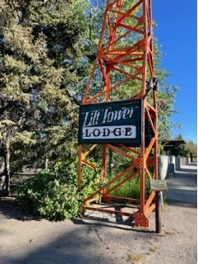
Lift Tower Lodge on S. Main Street
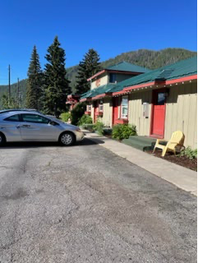
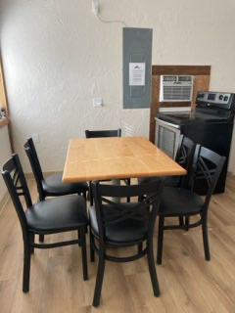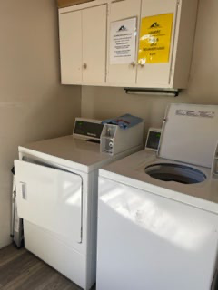
New Kitchen and Laundry Room for the 14 rooms at the Lift Tower Lodge

