Blaine County Charitable Fund 2021 Final Report
Grant Title: Emergency Grant Assistance Program
Grant Amount: $25000

Year in Review

There were many unknowns going into 2021 for Blaine County Charitable Fund (BCCF). The uncertainty about how COVID was going to continue to be a factor in driving crisis, the long-term effects that depleted resources would have on households, or how the lifting of eviction moratoriums would cause instability were all difficult to forecast.

The second half of 2021 was the year to shape BCCF’s future. Thanks to the support of WRWF, BCCF was able to move confidently into its future role of providing stability and resiliency for all in Blaine County. In early 2022 BCCF’s need to expand bilingual staff and more in-person operations became clear. Moving from simply crisis intervention, to building stability and resiliency became clear. Becoming the most accessible rental assistance provider in Blaine County, BCCF is viewed as providing essential services, including services that are helping to solve the housing crisis.

Objectives & Outcomes

Goal #1- Provide swift help that aids in preventing loss of home or other life sustaining necessity:
Between July 2021 & June 2022, BCCF provided $128,,972 to 81 unique households. 73% of the assistance was applied toward housing needs, 14% towards utilities and 5% toward emergency medical. Applicants were polled the Fall of 2021 and 100% of the respondents shared that the assistance helped them avoid eviction.

Goal #2 - Ensure all that apply to the BCCF are treated with equity of service and access to resources:
BCCF processes applications submitted in English in Spanish either through website, via referral from local agencies, through our centralized drop off location in Hailey and at times over the phone when individuals cannot access a computer or lack physical mobility to receive a hard copy. BCCF attended food distribution times at the Hunger

Coalition to give in-person access to individuals that were already experiencing food insecurities and needed to learn of BCCF’s services. In the spring of 2022 BCCF also offered weekly in-person hours at the Hailey Library, and later in May daily office hours at a new physical office location located in Hailey.

Photos

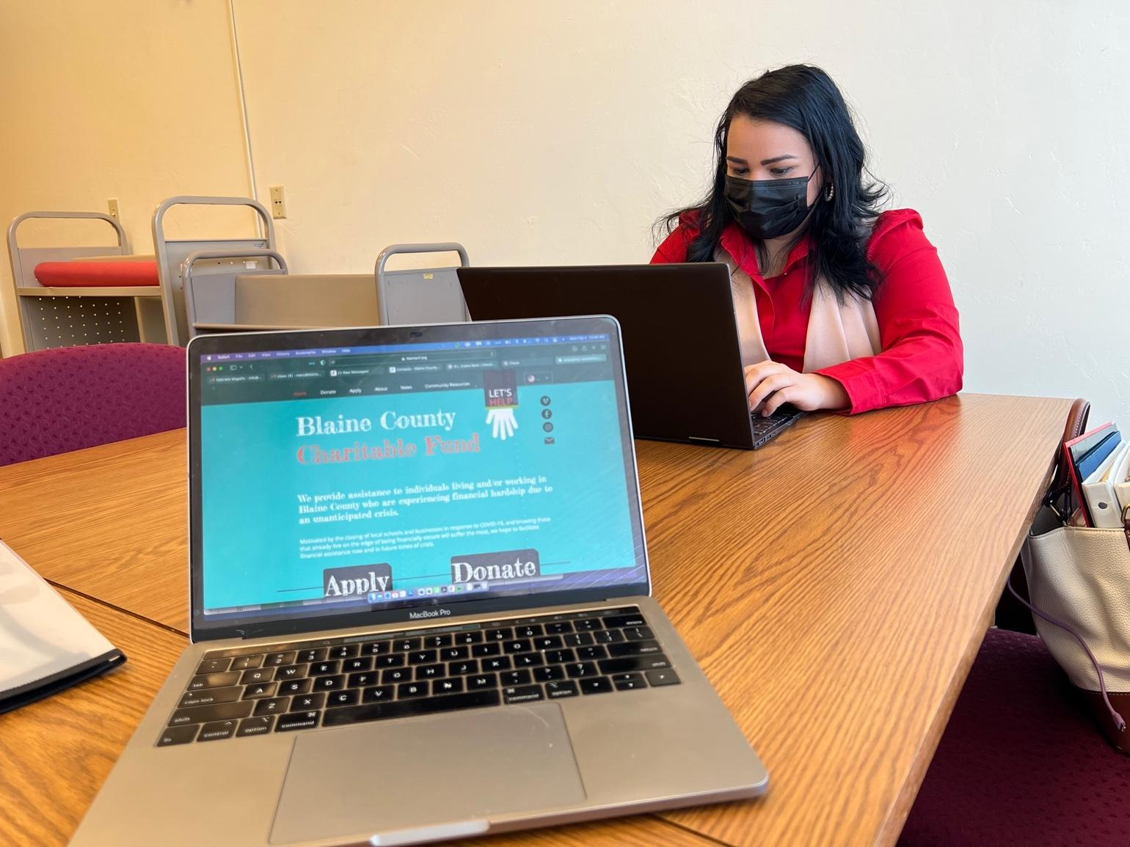

Budget

Expenses | Amount requested from WRWCF | Actual Expenditures
Salary and Benefits | 2,520 | 2,520
Advertising & promotion | 103 | 103
Emergency Grants | 22,030 | 22,030
Office supplies & software | 308 | 308
Insurance | 39 | 39
TOTAL | 25,000 | 25,000

