BLAINE COUNTRY RECREATION DISTRICT 2021 Final Report
Grant Title: Quigley Trails Park Infrastructure
Grant Amount: $25,000

Year in Review:

Quigley Trails Park has quickly become the most popular BCRD trailhead in both summer and winter. Skiers, bikers, walkers, snowshoers, sledders, and even equestrians have been using the 15km of Nordic skiing, the Quigley Loop Trail, and especially the Bike Park with two pump tracks, three flow trails, and three jump lines. Within minutes of the last bell of the school day, dozens of kids can be found riding their bikes to improve their skills and learn new tricks. Last July, we hosted our inaugural Pump Track Challenge, which had over 75 participants, and this winter, we hosted our first Full Moon Bonfire with almost 100 community members. Seeing over 50,000 user days, Quigley Trails Park is a hub in our community and funding from Wood River Women’s Foundation has created a welcoming space for recreationists of all sorts.

Objectives & Outcomes:
BCRD seeks to provide outdoor recreation access for residents in the population center of Blaine County. BCRD’s Quigley Trails Park has quickly grown into our most popular trailhead. After building the two pump tracks, three flow trails, and three jump lines, Quigley Trails Park has more than doubled its user days by expanding into a year-round facility. BCRD has reached new youth, which is visible by bike riders every day after school. BCRD is hosting the second annual Quigley Trails Park Pump Track Challenge on June 23, which had over 75 riders in its first year. Partners like SVSEF and Higher Ground, among others, have gravitated towards our accessible facility.
A challenge during the infrastructure phase of Quigley Trails Park has been paving a 100-spot parking lot. For cost savings, the paving project is associated with the adjacent development and will be completed when the development paves their streets, which is currently on track for Fall 2022.
Photos (see below)
Budget
Expenses | Amount Requested by WRWF | 2021 Actual Expenditures
Landscaping, Irrigation & Fencing | $25,000 | $35,548.93
Other Infrastructure Expenses |  | $15,612.89
Parking Lot | Still waiting on paving associated with Quigley Farms: planned in Fall 2022  Estimated at $150,000
TOTAL |  | $51,091.56

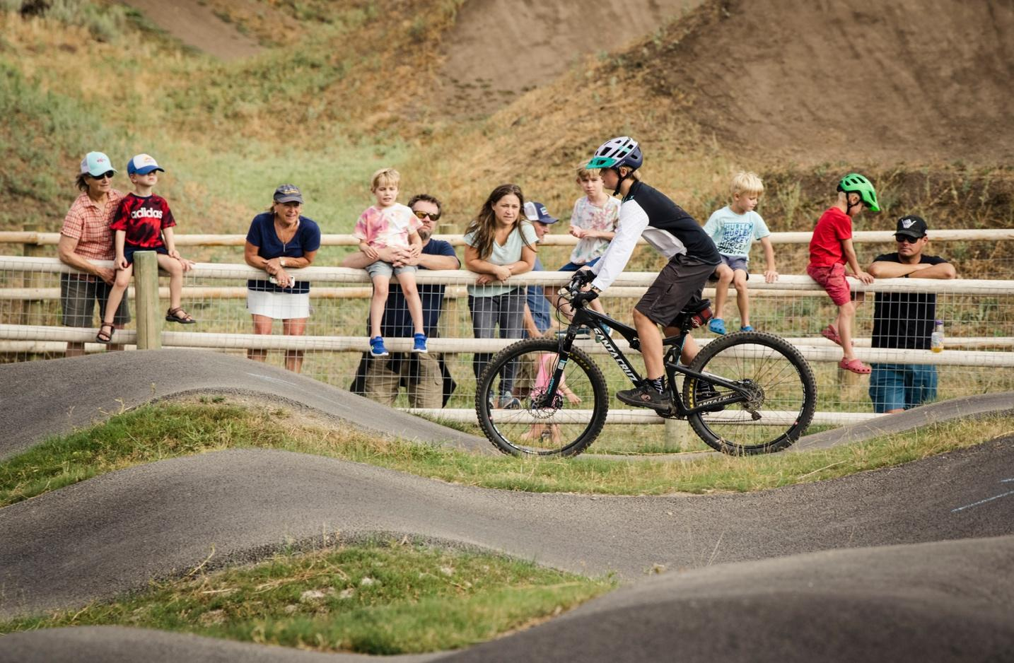
Friends and family cheer riders on at the inaugural Pump Track Challenge at Quigley Trails Park in July 2021.

High fives all around during the awards ceremony at the inaugural Quigley Trails Park Pump Track Challenge in July 2021
