BLAINE COUNTY EDUCATION FOUNDATION (BCEF) 2021 Final Report
Grant Title: Back on Track
Grant Amount: $25,000

Year in Review:
BCEF intended to provide academic support before / after school with BCSD staff. The staff was unable to add additional hours to their day. Luckily, other organizations stepped up to fill this need. Teachers were in need for classroom, curriculum support to help engage students. BCEF is reviewing their programs to ensure that we are providing the highest quality of academic support for students. We added an End of Grant Report to BCSD staff regarding grants from BCEF, so we can gauge measurable from the funds provided for academic support. This has also helped to build a relationship with the district to collaborate for academic support.

Objectives & Outcomes:
The funds provided academic support, but the look of the support changed. Instead of offering before/after school support, we offered curriculum support for teachers to engage students more effectively. We saw an overall increase from teacher requests from last year by 57%. Some teachers had a classroom budget of $250 for 350 students. They needed support to be able to provide materials for their students such as grocery cards for home economics class or special need students for culinary lessons (Federally required curriculum). Funds for decodable readers paired with the teacher’s literacy training. We now require an end of grant report for teachers that received funds that demonstrates academic measurable, such as the $2,000 request from WRHS Physical Science and new AP Biology class labs. They saw overall 10% lab grade improvement compared with physical science with virtual lab. This increased support for staff has led to build a stronger relationship with the district. Not only will this new relationship help us to collect measurable data from our support for classroom needs but also BCEF is part of the conversation and providing funding to support literacy curriculum needs at the middle schools for the upcoming 2022-23 school year.

Photos (see below)

Budget

Expense Type | Total Amount of Expense | Amount Requested | Actual Expenditures
5 after school elementary academic support | $7,000 each school for total of $35,000 | $10,000 | See attached chart
3 after school middle school | $7,000 each school for total of $21,000 | $4,000 | See attached chart
Digital Software support for school wide need | $15,000 in approximate need | $5,000 | See attached chart
Digital Software support for teacher | $5,000 in approximate | $2,000 | See attached chart
Salary for Program Support | $50,000 | $4,000 | $4,000
Total Expenses | $126,000 | $25,000

I shared a chart of teacher and school wide grants combined as a sample of the grants we funded with the WRWF grant in mind to support these requests. All of the requests were to support academic support of student learning; some were digital-based and others were basic needs to support the level of the student.
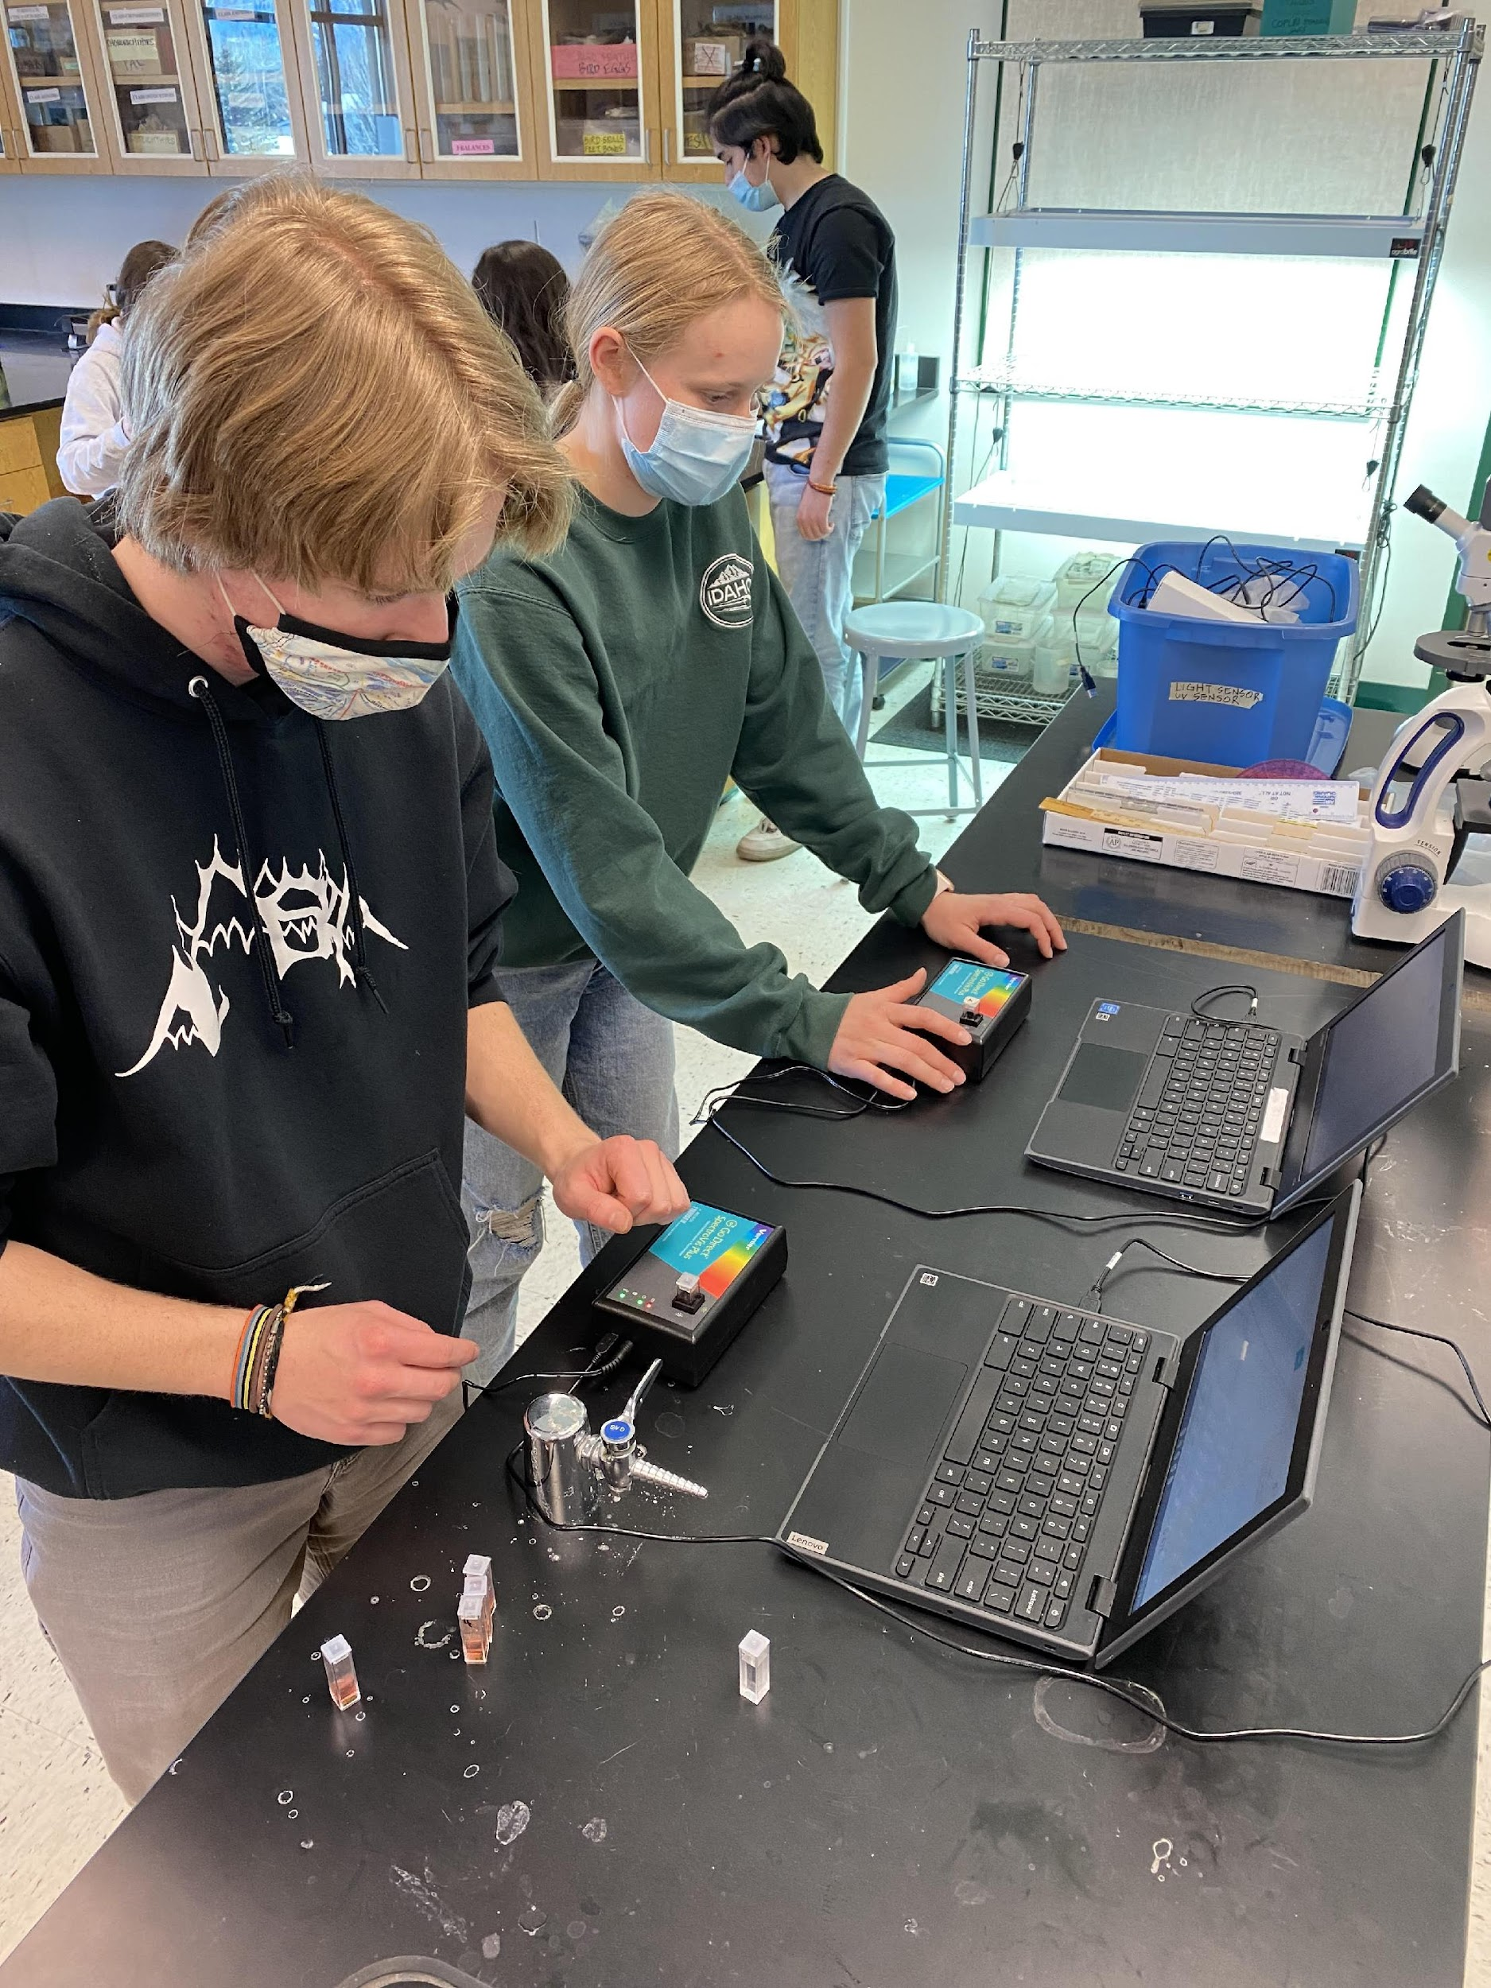
School | Subject | Amount Requested | Board Decision | Title | Description
WRMS  6-8th | ESL | $ 303.76 | $304 | Electronic Resources for Newcomers Class WRMS | Thinking Maps Individual License including the online Map Builder. Thinking Maps is a 1 yr license and Story board is 3 year. These have been great tools to help Esl students communicate tehir thoughts at a much higher level. Provide the opportunity for students to process, plan and create work with the aid of graphics and graphic organizers
Alturas  K-5th | Instructional tech | $ 2,500.00 | 2500 | Site License for Code monkey Coding Software Platform | used some of the free activities with students this year and found the them to be the most engaging that she has seen in the past 3 years of sampling platforms with students. Coding incorporates the four C's: Communication, collaboration, creativity, and critical thinking. These skills along with perseverance and problem solving are skills that will  promote success throughout students' school careers. When students get their code to work, they gain confidence in themselves and  experience a sense of accomplishment.The skill ofperseveranceprovides students with the motivationtowant to try to succeed in other academic areas, and students learn to persevere and never give up. Writing code is difficult. Students need to have the correct spelling and syntax- it has to be exact. Students build their self-control and confidence when they persevere and are able to get their code to work. Debugging and analyzing  for errors teaches and encourages problem solving and critical thinking.
WRMS  6 | Science | $745 | 795 | Subscription for generation genius science curriculum | The subscription cost decreases when purchase for more years - Would love a 5 Year subscription These were a great tool during COVId and found that they were updated and engaging for students
Alturas  K-5th | Engineering and Design | $ 3,500.00 | $ 3,500.00 | Vex Robots | If granted this funding, I would purchase a VEX 123 Classroom Bundle for kindergarten through 2nd grade students and the VEX GO Classroom Bundle for 3rd through 5th grade students. These VEX robotic products are considered the best robotic and coding products internationally for elementary students. They are the beginning robotic kits that will prepare the students for more advanced robotics and that align with the VEX robotic materials, classes, and competitions in our Wood River Middle School and our Wood River High School. I have included a copy of the prices in pictures below, and more information can be found at vexrobotics.com.
 |  |  |  | $0
School | Subject | Amount Requested | Board Decision | Title | Description
HEM  ALL grades | ELA | $3,858.40 | $ 3,859.00 | Leveled Texts for Readers | We are in need of level Q-V OKAPI - Flying Start to Literacy, paired texts for reading instruction. In next generation guided reading, students are doing most of the work. Teacher talk is minimized & teachers watch closely to gain insight into the reading processes happening. Guided reading is the final point of support before students reach independence. It offers teachers the unique opportunity to: 1. Observe students’ complete reading processes in action  2. Catch inefficiencies before they become habituated  3. Encourage students as they work According to leading reading researcher, Wiley Blevins, classrooms need a variety of both decodable and leveled texts in order to push students forward toward proficiency. Last school year, the Blaine County School District curriculum and development department purchased a small set of OKAPI - Flying Start to Literacy, Leveled Texts for each school. Unfortunately, the levels that were purchased only targeted middle readers in grades 1st-2nd. This has led to inequitable reading instruction for both teachers and the reading specialists on campus. Teachers do not have enough instructional materials at appropriate levels for students. Expected reading level by grade level can be found below in the attachment. We are in need of level Q-V texts. While these levels are considered benchmarks for grades 4th-5th we currently have students in grades 1st through 5th that are reading above/below grade level that need these levels. The funding of this OKAPI project will allow all students in grades 1-5 to benefit from small group instruction at their instructional level. It will provide 288 paired fiction/non-fiction texts at instructional levels Q-V.
BES  2nd | All Subjects | $450.00 | $ 450.00 | math & Science hands on Learning Curriculumn Support | Wooden Fraction Circles $53.95; Cut out Labeled Fraction Circles $42.95; Geometric Solids $52.95; Geometric Stick Material $84.99; Microscope $39.99-$59.99; 48 pack Microscope Slides $14.19; Plastic Science Trays 2 sets $56; Bamboo Cutting Board Sets x2 $50; Dissection kits need 6 - approx. $9 each;
WRMS  8th | English | $159.00 | $ 159.00 | The Thrill of Horror | I am asking for 24 books in the Five Nights at Freddy's Fazbear Frights collection. These scary stories have a lower Lexile level and can be read by the majority of my students. I have a large number of students reading at a 1st and 2nd grade level. The materials that I use in class are too high for them to read. I would like to provide these books for them to select on their own and read for pleasure along side the short stories we will read together in class for this particular unit.
WRHS  9-12th | English Lang Dev | $1,000.00 | $ 1,000.00 | Learning English through Reading | Our amount of newcomers this year skyrocketed. We currently have 20 newcomer students in our newcomer class. We are looking for resources to help this large population. One way to help newcomers learn English is through reading. This library is designed to help students develop their language though reading fiction and non fiction books. We intend to use this program as part of our newcomer curriculum. The ELL Teen Literacy Library is a collection of books that are written at lower level, but in a high interest subjects. Books focus on science, math and social studies but are written at a Lexile newcomers can understand and comprehend. As a school this year, we are focusing on student reading. This would be a great way for our Newcomer students to be able to read at their individual level with appropriate language and vocabulary supports.
WRHS  9-12th | All Subjects | $ 800.00 | $ 800.00 | Silent Sustained Reading | We intend to use this funding to purchase culturally responsive literature in primarily Spanish for students to read during silent sustained reading. These books will be kept in Advisory teacher classrooms for student use.
Carey  K-3rd | reading | $ 705.00 | $ 705.00 | Decodable Readers | Funds would be used to purchase multiple copies of decodable text at a primary level. This will allow small groups of beginning readers to begin "reading" as soon as they are introduced to a few letters/sounds.
WRHS  11-12^{t+} | Voice 2 | $ 500.00 | $ 500.00 | Groceries for cooking and budgeting skill lessons | For effective independence learning in the community, students need to know how to determine if they have enough money to make purchsaes. Primary shopping site for adults is the grocery store, help to navigate sales flyers, coupons, find prices in the store and to cook.
WRHS  9th | Physical Science | $ 1,000.00 | $ 1,000.00 | Solar Powered Ferrofluid Speaker Project and Phases of Matter Demonstrations | We will be purchasing consumable and long-term-use equipment with the grant. The ferrofluid project is an ongoing set of projects culminating in an end of trimester project build that ties together three separate units: chemistry, electromagnetism, and electricity. The second portion of the funds will be for demonstration of the phase changes of matter. What is amazing is that the ferrofluid project has students working towards mastery of ALL of the following standards:  HS-PS1-2: Simple Chemical Reactions  HS-PS1-3: Electrical Forces and Bulk Scale Structure  HS-PS1-4: Total Bond Energy Change in Chemical Reactions  HS-PS1-6: Increased Products Design Solution  HS-PS1-7: Conservation of Atoms in Chemical Reactions  HS-PS2-4: Gravitational and Electrostatic Forces Between Objects  HS-PS2-5: Electric Current and Magnetic Fields  HS-PS2-6: Molecular-Level Structure of Designed Materials  HS-PS4-1: Wave Properties in Various Media  HS-PS4-2: Digital Transmission and Storage of Information Specifically, via the standards above students are expected to explain magnetism theory, relate differences in large scale magnetic materials and nano-magnetic materials, describe the unique behavior of ferrofluids under magnetic fields, describe applications and uses for ferrofluids.
HEM  K-6th | Reading Interventions | $ 4,966.50 | $ 4,967.00 | Reading Interventions through Decodables | While all of the reading specialists and several K-2 teachers have been trained and are using the Orton-Gillingham Phonics-Literacy program, our school does not have high quality decodable texts for our students to apply the concepts that have been taught explicitly. Our decodable texts are black and white booklets that we staple together. We are not able to use these books with our older readers (3rd-5th grades). More importantly, they are not high-interest, engaging texts that encourage re-reading or writing activities. Benchmark Education Company has high quality, age appropriate decodable texts that will work for our struggling readers in all grade levels. By supporting this grant, BCEF will be putting wonderful decodable texts into the hands of all of our K-5 readers and helping us close the gap for our below grade level students
WRHS  10-12 | Biology/  Zoology/  AP Biology/  Botany | $1,000 | $ 1,000.00 | Lab Technology | The grant would fund the purchase of a Vernier SpectroVis spectrophotometer, a MiniOne Gel Electrophoresis system, and four pipettes (100-1000 and 20-200) for related lab activities. We have previously purchased MiniOne Electrophoresis systems but need one more to have a lab set for experiments in genetic analysis. These MiniOne systems provide access to many biotechnology labs that are otherwise difficult to implement in a high school laboratory. The SpectroVis spectrophotometer measures the absorbance of different wavelengths of light and would be used for a variety of experiments related to algae growth, photosynthesis, and enzyme catalysis. We have a supply of pipettes in the 2-20mL size but lack sufficient pipettes of larger volumes for class lab activities. Four additional pipettes would provide adequate coverage and prevent cross-contamination issues that arise when student groups share pipettes. All of these items are durable and would last many years.
 |  |  | $ 14,440.00
