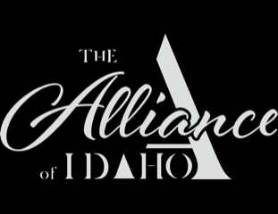

THE ALLIANCE OF IDAHO 2021 Final Report
Grant Title: Legal Support
Amount of Request: $25,000

Year in Review:

This was a big year for The Alliance, thanks to the support of the WRWF:
- Becky Lopez became the Executive Director in July 2021
- That same month, we moved into our gorgeous office at the Hunger Coalition
- We built a Latino/x/Hispanic-majority Board of Directors
- We also began contracting with immigration attorney Luis Campos, who travels to Bellevue for a week every month to meet with clients and offer consultations

When Becky answers The Alliance’s hotline, callers say, “They told me to call you” or “They said I could trust you.” And the need for ethical and affordable legal services is only increasing. Becky is one of two Latina EDs in the valley; Luis is the only bilingual immigration attorney in the valley; and The Alliance is the only group that takes on asylum cases in Blaine County. Under Becky’s leadership, we have become a trusted resource for legal services and for connection to other social services.

Objectives & Outcomes:

What we’ve accomplished from July 2021 through May 2022:
- Our legal team clocked 337 hours;
- Luis Campos offered 109 one-hour consultations to new clients in our community;
- The Alliance took on 19 asylum cases;
- We helped a family of 15 escape Afghanistan (which helped us better understand how to support refugees in our own community); and
- We offered several community workshops on filing taxes taxes and applying to college and for financial aid if you’re from a mixed status family.

Photos (see below)

Becky Lopez and Luis Campos

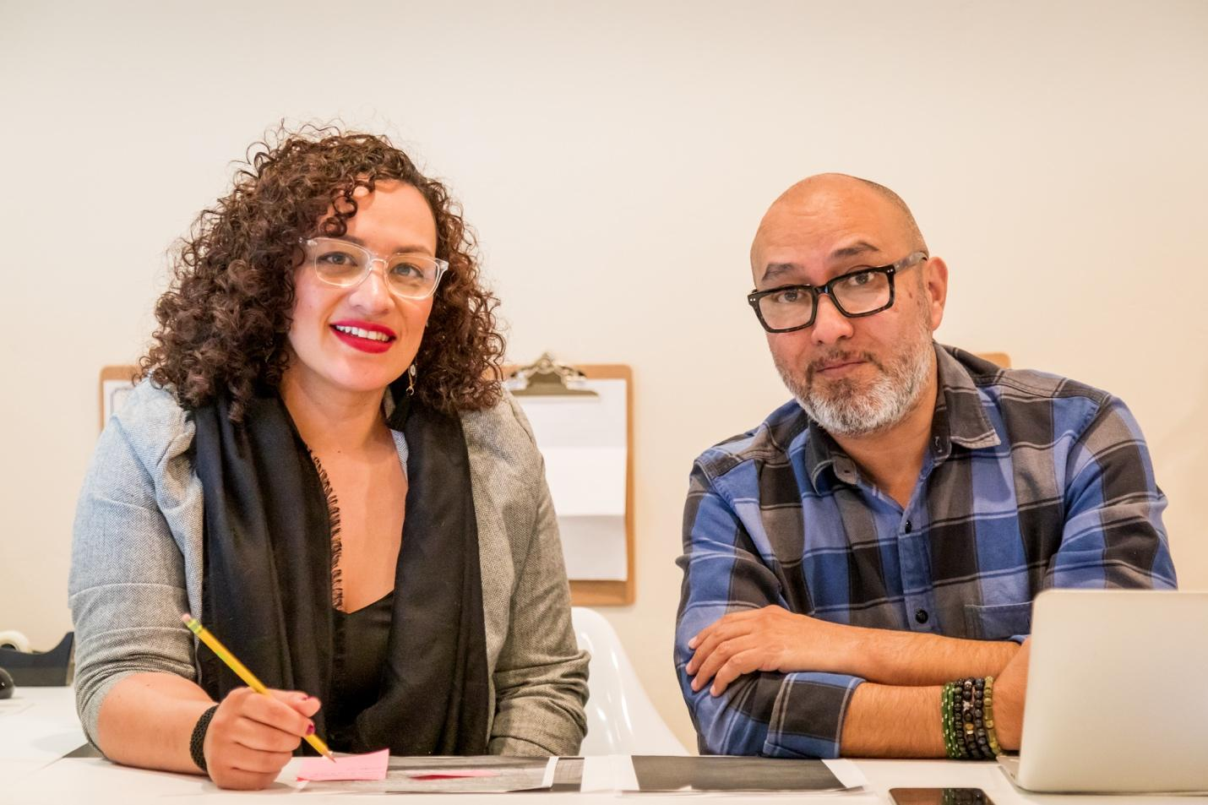

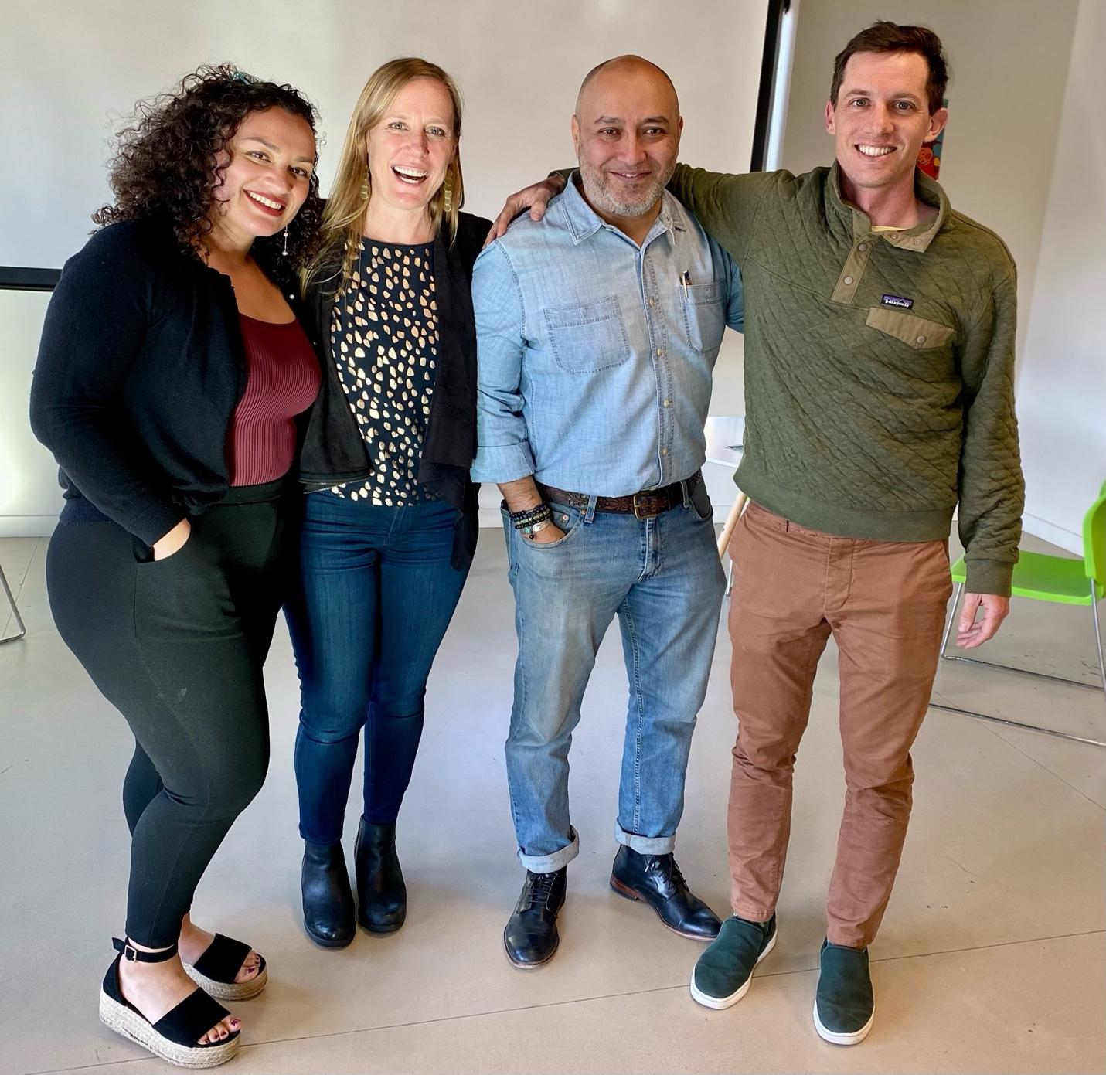

Budget

Expenses | Amount requested  from WRWCF | Actual Expenditures  from July 2021 to May 2022
Contract Fee for  Legal Services | $25,000 | $50,550
TOTAL | $25,000 | $50,550

